THREE
COLLEGES
PRIMITIVE METHODIST
SECONDARY EDUCATIONAL
VENTURES

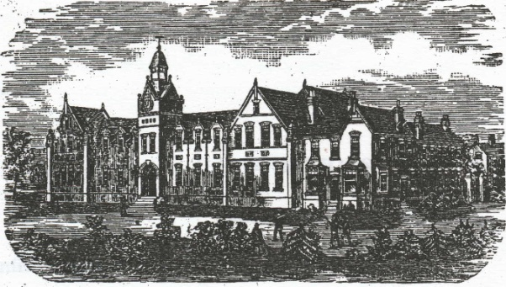
Bourne College

THE EIGHTH CHAPEL AID LECTURE 1998

ENGLESEA BROOK

by Dr E. DOROTHY GRAHAM

THREE
COLLEGES
PRIMITIVE METHODIST
SECONDARY EDUCATIONAL
VENTURES

Bourne College

THE EIGHTH CHAPEL AID LECTURE 1998

ENGLESEA BROOK

by Dr E. DOROTHY GRAHAM

First Published 1998
Re-published with minor corrections and resetting July 2015
© Dr E Dorothy Graham

CONTENTS
Preface and Acknowledgements 1
Chapter 1 - The Background 2
Chapter 2 - The Jubilee School, Elmfield College, York (1864-1932) 6
Chapter 3 - The Ladies College, 5 The Cedars, Clapham, London (1874-1881 Or 1887) 20
Chapter 4 - Bourne College, Quinton, Birmingham (1876-1928) 26
Chapter 5 - Conclusion 42
Appendix 43

ILLUSTRATIONS (after Appendix)
Elmfield College
Advertisement for Elmfield College
Bourne College (exterior)
Bourne College (classroom; dining hall; laboratory; dormitory)
Governor and Matron of Bourne College
Headmaster of Bourne College

THREE COLLEGES: PRIMITIVE METHODIST SECONDARY
EDUCATIONAL VENTURES

PREFACE AND ACKNOWLEDGEMENTS
Many years ago Mr. Joe Hunt, the then Director of the Birmingham and Midland Institute, spoke briefly to the West Midlands Branch of the Wesley Historical Society about the Primitive Methodist Boys School, Bourne College in Quinton, Birmingham and the Branch visited the building just before it was demolished. Years later two elderly ladies, whose family had had associations with the school, gave me some boxes containing the school magazine and other archives. I deposited many of these in the Birmingham Reference Library, others went to the Methodist Archives and some to Englesea Brook.
I always promised myself that 'one day' I would write up the history of the Bourne College and the impetus came when I was asked to give a lecture, with a West Midlands flavour, to the first conference of the Association of Denominational Historical Societies and Cognate Libraries in July 1995. My appetite having been whetted I vowed that, again 'one day', I would look at Elmfield College, York and the Ladies College, Clapham. So this invitation to give 1998 Chapel Aid Lecture provided that opportunity.
Primitive Methodism was anxious to provide a good thorough education in the context of sound religious teaching for its young people and so the Connexion embarked upon these ventures. I have tried to bring together what information I could find about the three colleges, so that a little known story could be told. Although in both chronological terms and significance Elmfield College was the most important of Primitive Methodists Secondary Educational institutions I do know more about the Birmingham School as it was on my very doorstep and I was fortunate to have records to hand, so I am sure the reader will understand why I am able to give more detail about Bourne College.
As well as the people and societies mentioned above and acknowledgements made in the text thanks are due to many more friends for their encouragement and advice, but particularly to the Rev. John Banks for overseeing the actual production of this booklet.
My hope is that this slight work may encourage others who have more personal knowledge, records or papers relating to the Primitive Methodist Colleges to share them with a wider audience.

E. Dorothy Graham
March 1998

CHAPTER 1 - THE BACKGROUND
Primitive Methodism, which originated in the borders of Cheshire and Staffordshire around the area of Mow Cop, was from the beginning concerned with 'education', albeit not necessarily of the formal type. John Wesley had always encouraged his preachers to read and study and the Primitive Methodists did the same, largely at the instigation of Hugh Bourne. Hugh Bourne himself was taught to read and write and do simple arithmetic by his mother. Then he was sent to school in Werrington and later Bucknall where he learnt reading, English, grammar, arithmetic, easy measurement and the rudiments of Latin. He continued to study after leaving school - tackling more arithmetic, geometry, astronomy, natural philosophy, history, geography and the Bible and religion in particular and 'there is evidence that in later years he gained considerable knowledge of Hebrew, Greek, Latin and French.’
Following Hugh Bourne's example and precepts Primitive Methodism was very strong in its advocacy of self-help and self education. Bourne, in addition to purchasing and passing on tracts, wrote and published many himself and the preachers were urged to purchase suitable literature from the travelling preachers, who were agents for books, pamphlets or tracts produced by the Connexion or authorised by it. The travelling preachers were entitled to a 10% discount on the books they sold to encourage them to study and to educate their hearers. A number of the travelling preachers who had little formal education did educate themselves to very acceptable standards so that they could more effectively minister to their people. No doubt, by some standards, their education was sadly lacking, but the very fact that they were required to keep and present journals to the Quarter Day Meetings ensured that at very least they had the rudiments of good English. The extracts from their journals, articles and sermons, many of which were published in the Primitive Methodist Magazine, read to enquirers or congregations, show a considerable grasp of language, even if a little formal in style, and a practical common-sense view of life and its vicissitudes. It was not regarded as peculiar by the travelling preachers themselves or by their hearers that they were not highly educated. After all the preachers' mission was chiefly to the poor people who had not had the advantage of much education themselves and who therefore did not see the lack of it - or perhaps even the need for it - in their preachers. Much of the evangelism was carried on in the homes of the people by 'conversation preaching' and a burning evangelistic fervour for the saving of souls rather than erudition was considered important.
In the early days most of the travelling preachers on probation, which lasted for four years, learned on the job' and were expected to study, in addition to their preaching and visiting, in order to improve themselves in the fields of education, preaching and pastoral care. There is a series of articles in the Primitive Methodist Magazine which gives much practical, common sense advice. As the century progressed and congregations became more knowledgeable and sophisticated they demanded better educated ministers and so the need for a more professional approach and a formal programme of ministerial training became evident. It now became necessary not only to provide teaching for converts, but for members and their children so both ministers and congregations began to demand more specialised training. Therefore, as we shall see, in 1865 a one year training course for ministers was set up at Elmfield College. York, followed by the establishment of a theological college in Sunderland in 1868.
Primitive Methodism's venture into formal secondary or middle-class education came through the travelling preachers, who felt that their own children suffered because of the itinerant system and that their salaries, especially as many had large families, were insufficient for them to pay even for 'common schooling,. A writer, using the nom de plume 'Aleph', contributed an article to the Primitive Methodist Magazine on February 2nd 1847 'On a School for the Children of the Itinerant Preachers' in which he advocates the desirability of 'the establishment of a Connexional School, in the central part of the kingdom, for the children of Primitive Methodist Itinerant Preachers'. He insists that
'A superior education I do not ask for, but to a respectable education I think the preachers' children are entitled' and that the consequent relief to the family would mean that the 'father (would) know that while he cared for the churches they cared for his family'.
A Conference resolution on the subject was endorsed by the Reading Circuit, but the response from the Connexion's authorities was not encouraging:
'we beg to say that the Educational Committee has done nothing officially … respecting the Institution …
It seems that the Book Room's surplus profits were to be used to establish the Institution, but a decrease in missionary money received from circuits had meant that the General Treasurers had had to borrow money from the Book Committee to pay the missionaries' salaries and therefore the Educational Committee felt unable to proceed for the moment. Characteristically the reply urges the missionaries, preachers and circuits to work hard to spread the Gospel and become self-supporting so that money could be made available.
The Consolidated Minutes of 1849 noted:
‘We have three kinds of Connexional schools, and one kind in prospect, namely, Sabbath, day, and night schools: the one in prospect is designed for the education of preachers' children.’
and it then set out the full proposal for
'A SCHOOL FOR THE EDUCATION OF ITINERANT
PREACHERS' CHILDREN
- An attempt should be made, at a prudent time, to form a school.
- It shall be ascertained what can be raised towards the commencement of such a school, in order to decide whether it will be possible to establish one or not.
- The General Committee shall have liberty to raise funds, in such parts of the Connexion as will give permission, by the influence of friends and by public contributions, and to draw up provisions respecting the support that shall be allowed for each child to the Institution by the parents.
- In further pursuit of this object, there shall be used for the support of the Institution the profits arising from our Book-room's business in London, other prior claims having been first paid.
- If the Institution can be raised, convenient premises shall be rented for the purpose, till it shall have been ascertained whether the Institution can be permanently supported or not.
- If there is a likelihood of forming the Institution, several of the most economical and useful educational establishments in the kingdom shall be visited by a member of the Education committee, that he may obtain for the Committee the best available and workable provision of such establishments.
- Should the institution be formed, it shall be economically conducted, the children to be taught useful branches of learning, as well as domestic work; the girls to work for themselves, and cook , and sew or make their own apparel, and the boys to clean their own shoes, and attend to any work about the establishment,, so as to teach them habits of industry, and prevent the cost of hired labour.
- Should the Institution be formed, male or female teachers shall be provided, of good moral, intellectual, and literary qualifications; and there shall be a governor and a governess of suitable character, to whom shall be committed the management of the children's moral and domestic habits, their victuals, washing, sewing, and other interests not devolving on the teachers.
- The General Committee shall be the Education Committee; and when the fit time for action shall have arrived, it shall attempt to form the establishment, and shall have supervision of it, and the preparing of future regulations for the Conference's consideration respecting it.'
Obviously Primitive Methodism recognised the need for an educational institution particularly for its preachers' children, but was not at that time in a financial position to be able to establish one. We must remember that, by and large, the congregations were of the artisan class and their wages were only about the same as the preachers' salaries and therefore few could give money towards such an enterprise.
In 1858 the Connexion decided to hold a Jubilee in 1860 to celebrate the formation of the first Class Meeting in 1810 and that 'the chief end of the said jubilee shall be, the spiritual benefit of the Connexion'. One of the ideas was to have a Jubilee Fund and among other objects to establish,
'A school for preachers' children, and the children of members.'
At long last it seemed as if those hopes entertained for so many years were about to be realised.

CHAPTER 2 - THE JUBILEE SCHOOL, ELMFIELD COLLEGE, YORK
(1864-1932)
THE DREAM FULFILLED
The Rev. Dr. Samuel Antliff suggested at the 1859 Conference that the Jubilee Committee should make enquires in all the Districts about the possibility of establishing such a school. A property was offered in Hull, but it was deemed not suitable. Antliff persevered, visiting many schools and submitting a report in 1861, but it was not even read nor any mention made of a school. However he had more success in 1862 when a Committee was appointed `to select a site of land or premises for a school and to draw up regulations for the working of the school, and submit them to the next Conference for its consideration.' Just before the 1863 Conference the Elmfield estate in York was chosen. so Conference agreed to 'The Establishment of a Connexional Jubilee School', the property was purchased and the deeds. along the lines of the Connexional Model Deed, drawn up. Samuel Antliff became the Secretary and the Rev. John Petty was appointed as the first Governor, with his wife as the Matron.
The Primitive Methodist World in 1883 giVes the following description:
`Elmfield College is pleasantly situated in the vale of York, about a mile and a half from the centre of the ancient city. The Hambleton Hills are very conspicuous about twenty-five miles there from to the North, as are those of the Yorkshire Wolds about fourteen miles to the East. ‘The college was the outcome of a strong conviction that if the Connexion did not provide thorough and liberal education for the sons of our ministers and prosperous laymen, we should not retain them in communion with us. The blessing of God upon the industry and economy of our people has raised many of them into comfortable circumstances, and enabled them to provide somewhat liberally for the education of their sons. So long as these sons had to receive their scholastic training in the schools provided by other denominations, they would be influenced by the doctrines and ecclesiastical principles of such denominations and would most likely be alienated from us.'
Twenty regulations were listed for the running of the school and dealing with the acquisition and furnishing of the premises on the Malton Road. Boys only, aged between the ages of nine and fourteen and vetted by the managing Committee were to be admitted, except in special circumstances. The fees were set at £20 per annum for the under 12s and £25 for older pupils, but the travelling preachers only had to pay £15. There were arrangements made for free scholars, who had to be 'fatherless son(s) of a Primitive Methodist', to be admitted. Subscribers to the school were given a say in the selection of such a free scholar. In accordance with Primitive Methodism's ethos the Managing Committee, appointed by Conference, was to consist of two-thirds Laymen and one-third Ministers. The Governor was always to be a Primitive Methodist minister, who would take care of the pupils' moral and religious training as well as having general oversight of the school, with his wife as Matron. It was decreed that 'The Education shall be Religious, Commercial, and Classical'. The 1864 Conference authorised the purchase of the property for £1,350, approved the building plans, appointed Trustees to act as the Managing Committee of the school and property, agreed to the acquisition of another house for an extension and reaffirmed the appointments of Mr. and Mrs. Petty with Samuel Antliff as Secretary and Alderman Meek as Treasurer. Until 1906 there was both a Governor and a Headmaster at the College which opened on January 26th 1864 with James Kyle Dall B.A. as the first Headmaster. It was perhaps particularly opportune that Conference was held that year in York and so the boys were taken to it where they were addressed by the President, the Rev. James Garner.
Laymen and one-third Ministers. The Go^{v}ernor was always to be a Primitive Methodist minister, who would take care of the pupils' moral and religious training as well as having general oversight of the school. with his wife as Matron. It was decreed that 'The Education shall be Religious, Commercial, and Classical'.¹- The 1864 Conference authorised the purchase of the property for 0.350, approved the building plans, appointed Trustees to act as the Managing Committee of the school and property, agreed to the acquisition of another house for an extension and reaffirmed the appointments of Mr. and Nits. Pett^{y}' Samuel Antliff as Secretary and Alderman Meek as Treasurer. ¹³ Until 1906 there was both a Governor and a Headmaster at the College which opened on January 26th 1864 with James Kyle Dall B.A. as the first Headmaster. It was perhaps particularly opportune that Conference was held that year in York and so the bo^{y}s were taken to it where they were addressed by the President. the Rev. James Gamer.
We have already observed that up to this time, Primiti^{v}e ;Methodist ministerial training had been chiefl^{y} teamed on the job, but now that an educational institution had been established it was decided in 1865 that ministerial student^{s}, with John Petty as their tutor, should be admitted to Elmfield. Their fees were set at £30 per annum for board, lodging, washing and instruction; and each student or his friends had to find at least half of that amount. A large committee was formed to cam' the Conference's resolutions and it was hoped that one student from each District would go to Elmfield to commence their studies on July 25th 1865. The Committee was further charged with the task of raising the extra mone^{y} needed to cover the shortfall in the fees.
candidate for the Primitive Methodist ministry had to be endorsed b-N, his local station. his application to go to Elmfield submitted to the Education Committee and if accepted his name was recorded on the Reserve List of ministers. An annual progress report was to be sent to the General Committee on or before 1st May. ¹⁵ It seems that initalhtwelve ministerial students were to be accommodated and arrangements were made for future students. Obviousl^{y} the Connexion was determined to see that it got value for any money expended. By this time the Connexion had realised that ministerial training had become essential and that this aiTangement at Elmfield was only a first step. So the 1866 Conference appointed small committee `to look out for suitable premises, should they be required, for a Ministerial Candidates' Institution and to report to the next Conference.' ¹⁶ A suitable building in Sunderland was found and it was agreed that the first Ministerial Training Institution should be established there under the care of the Rev. Dr. William Autfiff.¹⁷ So the temporary stop-gap of some ministerial training at Elmfield ceased and more specialised training commenced. ¹⁸
The College's first printed balance sheet for the year ending December 31st 1866 showed a healthy balance of f1690.15.0.1y The 'Conference Address to the Stations'
- PMMins (1863) pp.33-4 (1-20)
- PMMins (1864) pp. 36-7 (1 -11)
- PMMins (1865) pp.35-38 (18). 96
- PMMins (1866) p.41
- PMMins (1866) pp. 44- 5
- PMMins (1867) p.46
- G. E. Milburn, A School for the Prophets (Chapel Aid Lecture, 1981)
- PMMins (1867) p.80
7
We have already observed that up to this time, Primitive Methodist ministerial training had been chiefly learned on the job, but now that an educational institution had been established it was decided in 1865 that ministerial students, with John Petty as their tutor, should be admitted to Elmfield. Their fees were set at £30 per annum for board, lodging, washing and instruction: and each student or his friends had to find at least half of that amount. A large committee was formed to carry out the Conference's resolutions and it was hoped that one student from each District would go to Elmfield to commence their studies on July 25th 1865. The Committee was further charged with the task of raising the extra money needed to cover the shortfall in the fees . A candidate for the Primitive Methodist ministry had to be endorsed bv his local station, his application to go to Elmfield submitted to the Education Committee and if accepted his name was recorded on the Reserve List of ministers. .An annual progress report was to be sent to the General Committee on or before 1st May. It seems that initially twelve ministerial students were to be accommodated and arrangements were made for future students. Obviously the Connexion was determined to see that it got value for any money expended. By this time the Connexion had realised that ministerial training had become essential and that this arrangement at Elmfield was only a first step. So the 1866 Conference appointed small committee ‘to look out for suitable premises, should they be required, for a Ministerial Candidates' Institution and to report to the next Conference.' A suitable building in Sunderland was found and it was agreed that the first Ministerial Training Institution should be established there under the care of the Rev. Dr. William Antliff. So the temporary stop-gap of some ministerial training at Elmfield ceased and more specialised training commenced.
The College's first printed balance sheet for the year ending December 31st 1866 showed a healthy balance of £1690.15.0. The –‘Conference Address to the Stations' contains a summary of its Report to the Conference and indicates that good start had been made and that the school was 'in scholastic publications now placed among the colleges and first class boarding schools in the kingdom'. While it was regretted that not all the students had been converted the spiritual state of the school was satisfactory and former students were acquitting themselves well their chosen professions - three former scholars were teaching at the school. As an example of the worth of the school it was reported that an unconverted entrant was converted, became a local preacher, returned as a ministerial candidate and was even then awaiting stationing.
The College suffered a severe blow in April 1868 when the Governor, John Petty. (1807-1868) died aged sixty. The Conference appointed the Rev. Thomas Smith in his place. Samuel Antliff, who had been the prime mover of the establishment of the College and who as Secretary had steered it through its early years, retired in 1869 and the Governor took on that responsibility as well. The 1869 Report is the first one actually printed in the Primitive Methodist Minutes and it recorded that with ninety-two pupils the College had been the second best in Yorkshire in the Cambridge Local Examination results, which was considered to be remarkable given its short existence and was surely a tribute to the dedication and hard work of both the staff and the students. The spiritual side of the school was flourishing too. Unfortunately the accounts showed a deficit of £130. 17 5d., but this was put down to the loss of income due to the transference of the ministerial students to the Sunderland Theological Institute, improvements to the property which included
'refurbishing the sleeping apartments of the boys with blankets, rugs, etc. to promote their warmth and comfort during the winter'
and various external factors. The debt of more than;.£5,000 on the premises was also causing concern. The school register showed that of the ninety-two scholars seventeen were Primitive Methodist ministers' sons, including one free scholar, and two were day pupils, so it seems that the College was serving the purpose for which it was set up - to provide education for the travelling preachers' sons and 'the sons of our wealthier friends at York'.
A brief snapshot of one of the earliest pupils at the College to give a flavour of those first few years. The Rev. Dr. Edwin Dalton (1845-1825) had entered Elmfield in 1865 at the age of twenty set upon a commercial career. He had had little previous schooling and found the work difficult at first, but persevered. He enjoyed his time at the school finding Mrs Petty, as Matron, efficient and caring, and the two daughters, who acted as assistants in the College. very different young ladies, but devoted to the good of the establishment. The students came from varied backgrounds, but all had sincere religious intentions. Coming under the spiritual and theological influence of John Petty Dalton became convinced of his call to the Primitive Methodist ministry and so joined the ministerial training course. Apparently the theological students were allowed to take services in the York circuit to gain valuable experience before they entered fully into circuit work. When Dalton left he was first stationed at Ripon and in due course had a distinguished ministry, which had started at Elmfield under the guidance of the first Governor and to which he paid tribute by continued interest in the well-being of the school. He died during the 1925 Conference.
The Reports to the 1870 and 1871 Conferences were on the whole satisfactory in respect of the care of the property, the reduction of the debt, the spiritual and physical health of the pupils. The Headmaster, J. K. Dall, left after seven years at the College and W. J. Russell B.A. was appointed. The 1872 Report was delighted that some influential non-Primitive Methodist members of York society had sent their sons to Elmfield and had furthermore recommended it highly to their friends - it seems that Elmfield had arrived!!! The school was now full and half the expected vacant places in June already filled. The financial debt was being reduced and the examination results were outstanding with all thirteen entrants passing and seven of these achieving honours. Another indication of its success was that three Exhibition scholarships of £10 each were now being offered and this was enhanced by the Conference decision to institute a Conference grant of £25 to be known as the Hugh Bourne Scholarship which was to be awarded annually. During 1872-3 plans were drawn up for a building to act as sanatorium, but a house and four acres of land nearby became available and so this was purchased for £925 instead. A chemistry class had been formed to train boys to become 'druggists'. Again the reduction of the debt, the religious and physical state of the pupils, their scholastic achievements and the increasing number of scholarships being offered is highlighted. So after a decade the school's future was on an even keel and hence forward we shall only note items of outstanding interest.
UP AND DOWN
In 1875 the Committee requested Conference's permission to erect additional premises - 'master's rooms, class-rooms, lavatory, laboratory for chemical operations, and bath-room' at a cost of not more than £2,000. The buildings were completed during 1877, when it was observed that although chemistry had been taught for a while no specialist laboratory had been available before, but now the boys could have practical instruction which would fit them for careers in the sciences. A gymnasium had also been added and regular physical training and athletic classes given. From this it can be seen that the pupils were receiving an all-round education of academic studies, healthy, exercise and spiritual values. By 1879 the academic prowess of the school was sufficient for four students to have matriculated at London University - including W.H. Hodgson, a junior master, who gained honours.
The College rejoiced in the reflected glory when the Governor was made President of the Primitive Methodist Connexion for 1877-8 and in 1878 the Rev. Robert Smith was appointed as the vice-governor. Although this was in line with the rest of Primitive Methodist institutions presumably it is also an indication that the College was firmly established with more attendant administration, so, especially during the Governor's Presidential year, additional help would be welcomed. There must also have been the thought that the vice-governor would familiarise himself with the organisation of the College, so that in due course he would be able to take over. As indeed happened all too soon when once again the school lost its Governor - the Rev. Thomas Smith (1814-1879) dying in harness on 29th August 1879. Though he had been seriously ill for about a year at the end of July he became confined to bed at the College. The boys maintained quietness and discontinued their hymn-singing in case it disturbed him, but he requested it be resumed so that he could enjoy it. His family continued to look after the college until Christmas when the Vice Governor, Robert Smith, was formally appointed as Governor and Secretary. Dr. Raby was Headmaster from January 1878-April 1879 before Thomas Gough B.Sc., F.C.S succeeded him.
For the first time in the College's eighteen years existence the 1881 Report attributes a fall in numbers and consequent loss of revenue to bad weather, poor harvests and Connexional depression which had caused the withdrawal of several boys. This indicates the background from which many of the pupils came - the original agricultural and artisan class of early Primitive Methodism and its later movement into the business and commercial spheres all of which were very dependent on the seasons and trade. However, academic successes continued with J.W.T. Stafford passing the London University 1st B.A. examination - this was the highest achievement to date, but others soon followed. Many of the successful examinees were noted as sons of Primitive Methodist Ministers. One wonders if this was high-lighted particularly, to show the growing erudition of Primitive Methodism and its ministry as well as the all-round good standard achieved by the school and also to reassure Conference and the Connexion that the College was worthy of being a Connexional Institution and that the time and money invested in the venture was not being wasted.
The Report of 1883 is fascinating as its description of the improvements and their cost by implication gives some idea of what life in the college was like in the early days:
‘…a good deal of special expenditure has been required. The school-room has been re-floored, and otherwise much renovated. The largest dormitory, which is to the north, has been warmed with hot water. The dormitories in general have been largely refurnished, not only with a view to replace worn-out material, but chiefly with the -view to the boys sleeping in single beds, and also for the purposes of health. A new cooking apparatus, as an aid to the original one, has been provided for the kitchen, and important service of hot water has been supplied both upstairs and downstairs. The dairy and other departments, not infrequently subject to flooding, have been effectually drained. A new gas meter and other essential appliances have been obtained. The premises are much older and much larger than they formerly, were. and consequently cost much more in working expenses and keeping in repair. Hence our balance of profits this year is only, very small.'
A literary and debating society, was formed at which papers, readings and essays were presented and followed by criticism and discussion. A monthly school magazine, The Elmfieldian edited by G. H. Atkins, J.E. Allenby and F.G. Bowe had been started.
The 1884 Annual Address to the Conference stresses that although the Educational Institutions enjoyed much academic success that was not the whole story and that:
‘there was reported to have been a gracious work of God, through which several boys had been led to join in the fellowship of the church … our great concern is with the heart and with winning men to the knowledge and love of God.’
A typically Primitive Methodist comment!! This aspect is emphasised and a little insight is given into the religious side of College life when in 1886 we learn that the boys had Scripture lessons, prayer meetings on a Sunday morning and twice during the week, daily morning and evening family worship, consisting of scripture readings, hymns and prayers, a preaching service on the Sunday afternoon and also met the Governor in a society class.
The Conference in 1885 set up a Committee of enquiry 'in relation to the management of the following Connexional Institutions viz.:- The Insurance Company. Bourne College, Elmfield College and the Ladies College.' The terms of reference were (College) to:
....examine the Trust Deed of the Elmfield College, in order to ascertain what provision is made for adding new Trustees or appointing a Committee or Board of Management, and shall forward their findings with such suggestions as they deem necessary to the next Conference.'
Fortunately the Committee produced very favourable reports on Elmfield and Bourne Colleges and they were commended as first-class institutions and parents who wished to give their sons a sound yet liberal education were urged to patronise them.
The Headmaster, Thomas Gough B.Sc., F.C.S. left in 1886 and William Johnson, B.A.. an old pupil and assistant master was appointed. He was supported by six resident assistant masters four of whom had been educated at the college.
The Primitive Methodist Magazine 1887 carried a notice about the formation of the Elmfield Old Boys' Club. The prime mover in this was R.S. Wray who had been educated at Elmfield and felt that such a club would provide a contact point for old students, help promote the educational opportunities offered by the school, support an Old Boys' Athletic Club and circulate information about the club and the school. Rules were drawn up, officers elected and monthly social meetings in London arranged, In time it was hoped to have branches in Manchester and Newcastle.
In 1887 Conference legislated that the term of office of the governors of the Connexional institutions should be five years or seven if a special case could be made out and that they could not be re-elected for another seven years. However, the time those already in office might remain was to be determined by the merits of each case and certainly George Middleton, the Governor of Bourne College stayed in place until his death in 1907 and in fact the following year Bourne College alone was excluded from this ruling. Also although vice governors were supposed to be appointed for all the Connexional Institutions for some reason again Bourne College was excluded. The Rev. Robert Harrison was named as the deputy at Elmfield becoming Governor in 1888 when Robert Smith superannuated. Unfortunately he was only in the post until Christmas 1890 when the ill-health of his wife forced him to resign. However, the Connexion managed to effect an exchange with his Vice-Governor, the Rev. George Seaman, who was stationed in the Sunderland Second Circuit and the Rev. John Gair became the new vice govenor. There were soon to be more changes for the Chairman, Dr. Samuel Antliff, died on February 2nd 1891 and the Headmaster for the last five years, W. Johnson, resigned in December, to be replaced by another former pupil, R.G. Heys, B.A., who had been one of the first entrants to Elmfield in 1864 and also from 1876-1882 the headmaster of the emerging Bourne College in Birmingham. Antiff's connection with Elmfield was commemorated by a oil painting which was placed in the dining hall.
In accordance with Conference's five year rule George Seaman retired in 1896 to be succeeded by John Gair with William E. Crombie as Vice Governor. The College prospered steadily over the next few years - the number of pupils and their health was satisfactory, examination successes were recorded, the debt on the property was gradually reduced and various improvements to the facilities, such as recreation rooms and a well stocked Library, were made.
By 1900 the balance in the bank had dropped dramatically and continued the following year. Unfortunately school numbers were falling too, so that in 1901 they were down to seventy. The 'increased facilities for higher education provided by local authorities' was blamed for the decline, however, by the end of the year things had improved somewhat. Crombie became Governor in 1901 and George F. Fawcett was appointed as his deputy. That year modem languages were afforded a more important place in the curriculum and full use made of the new buildings. A Special Report from the Connexional Educational Committee recommended that secondary education should in future be included in its remit, that a letter written at the Committee's request by the Headmaster of Elmfield should be considered and that the Governors and Headmasters of Elmfield and Bourne Colleges should join the Committee.
Yet another change took place in 1901 when the local chapel attended by the boys and staff was closed and sold. The 1901 January issue of The Primitive Methodist Magazine reported that 'York First Circuit wanted a better church and a better site in place of the old Stonegate Chapel. An excellent site was obtained on the main thoroughfare.' Besides other advantages was the fact that it would shorten the distance the Elmfield boys had to walk to the chapel. The foundations of a new church, to be named 'The John Petty Memorial Church' after the first Governor of Elmfield, were laid in November. The boys collected £20. 16s. towards the building fund and the then headboy, F. R. Jenkins, laid one of the foundation stones.
The Address to Conference commends Primitive Methodism's scholastic establishments in both fields of academic success and religious training:-
'Elmfield and Bourne Colleges continue their splendid work with growing zest. Apart from the financial improvement, which is so satisfactory, we rejoice in the high educational status which is reached. A very high level of merit has been obtained by many of our youths in the Universities' and College of Preceptors' Examinations. .And it is specially gratifying that so large a majority of the pupils voluntarily attend weekly class for Christian fellowship and spiritual instruction. Parents, anxious for their children's best culture, will do well to consider the peculiar advantages and claims of ‘Elmfield' and 'Bourne'.
and again
The Educational Institutions. Elmfield College at York. and Bourne College at Quinton have each had a distinguished career, and the last year has been equal to the high standard these establishments have reached in the past. The moral and religious quality' maintained in these secondary schools is doing much for the youths of our families to carry on that religious instruction and characteristic of the best home life, and the undivided aim of the Governors and headmasters has been. and is, along with the secular training imparted, to develop the worthiest type of character.'
1904 was an eventful year for it brought the sudden death of the Governor, William E. Crombie (1848-1904) on 30th April followed a fortnight later by that of his predecessor, John Gair (1844-1904). The Vice Governor was quickly pulled out of the Pickering Circuit to take over. After the death of the Governor, W.E. Crombie. the 1905 Aldersgate Magazine contained an appreciation of his life and work in which it noted that in his two and a half years as Governor he had been 'full of schemes for the welfare of the institution...' with the further comment that
'Mr. Crombie's last years at York were fall of untiring work. At the College he laboured hard to make the institution successful. His influence over the boys was wonderful. He identified his life with theirs and won their respect and affection. He threw himself into the religious work with his accustomed zeal and earnestness. and many of the lads began to live the Christian life under his guidance.’
Obviously Crombie had various plans in mind to make the school more viable and so his untimely death must have caused these to be shelved. It is idle to speculate whether the history of the College would have been rather different if he had lived to carry out his ideas. Although in their reports both the Chairman and the Secretary were, in the modem phrase, 'up-beat" about the improvement in finance and the increase in the number of pupils, one wonders how much was wishful thinking as the balance sheet does not seem to indicate much of an up-turn and indeed the postscript to the 1904 Report hints strongly that all was not well:
We have had under serious and protracted consideration the serious financial position of the College and its future Educational policy. We think it undesirable - especially in view of the prevailing uncertainty as to what course the Government may take in relation to Secondary Education - that we should come under State control on the condition of our receiving State support. At the same time we feel most keenly the financial strain. Hitherto there has been a grant for science teaching, but this now ceases, and the loss of it adds to the already existing difficulty of meeting our current expenditure. But this is not all - we are having to make increased provision for the teaching of Science by the enlargement of the present Chemical Laboratory and the erection of a new Physics Laboratory at a cost of £400 to £500. To add this to the Capital Account is exceedingly undesirable. It is, in our opinion, absolutely necessary not only to raise the cost of the extension but to extinguish the entire debt; and we appeal to the Conference and the Connexion to enable us to do this. Very generous offers have been made conditional upon the whole amount being raised ....
Signed on behalf and by order of the Special Committee Meeting held in Leeds. May 12th 1904.
THOS. H. HUNT. Chairman.
GEORGE F. FAWCETT. Secretary.
There is nothing to indicate that the Conference or the Connexion heeded this plea as the following year a large deficit, £454 11.6d. was recorded. The difficulties at The school were not helped by a serious epidemic of measles, which no doubt caused anxiety, disruption and extra expense. The Aldersgate reported that the examination results from Elmfield College were among the best in the country, but more important still was the high moral religious results. It was observed that a large number of the most successful Primitive Methodist ministers were Elmfield old boys. Then the comment was made
'As is well known these colleges are rather handicapped in these days through the development of Secondary Government Schools; but it is certain that the residential element is a great advantage at boarding schools. The Conference Secretary bore excellent testimony to the value of Elmfield,. when he said that four of his sons had been there.'
In 1905 Henry J. Pickett was appointed as Vice Governor, but he was destined never to become Governor as the school moved into another phase of its history. The situation was explained in a -Special Report' which stated that the financial position was extremely serious with a debt of £811. 12. 2d. the number of pupils at an all-time low of only fifty-nine, and with little prospect of improvement because of the changes in national policy on Secondary and Technical Education and the trade depression. Therefore on 9th April 1906 the Trustees and Committee of the College had, with deep regret, passed the following resolution:
'That owing to our inability to meet our expenditure the College be closed on or before December 31st of the present year.'
'That we apply to Conference for sanction to sell the premises.'
The resolution was confirmed at the meeting on 9th May and Conference concurred.
A NEW START
The first offer of the premises was made to the Orphanage Committee, but while they considered the matter a group of old boys raised enough support to purchase
‘the whole of the College property- for the amount of its liabilities, on the understanding that it would be continued as a Connexional Institution. The transfer was affected on the 18th of December last.'
Under the new regime the dual control by Governor and Headmaster ceased and the Conference no longer appointed a Primitive Methodist minister as the Governor. As a result of the altered circumstances of the College the Conference at first only paid half, but later reinstated the whole, of its £25.00 grant for the Hugh Bourne scholarship.
I think it is important to understand the new structure of the school and so I make no apology for quoting extensively from the Report of the Interim Board of Management to the 1908 Conference:
'The five members of the Old Boys’ Committee - .....who entered into the contract with the Trustees for the purchase of the College estate, on December 6th. 1906. took over the management on December 18th, 1906. Pending the formation of a company, in accordance with the proposals submitted to and approved by the General Committee, the ..... signatories of the contract of purchase formed themselves, with the addition of several friends, into an Interim Board of Management.
The school was re-opened under the three-term system, the new- Board being of the opinion that the quarterly term system had contributed to the deterioration of the school.
The January term (1907) commenced with only 18 boys, the summer term with 20 boys, and the autumn term with 31 boys. Mr. Stanley R. Slack. B.A.. (Lond.). who filled the position of House-Master from Jan. 1892, to July, 1899, was appointed Head-Master."
The Board considered seriously whether the school should be run as a Secondary School with Government aid or "as a high-class Boarding School depending on its own merits." After making many enquiries the latter course was decided upon with the Cambridge Local Examination as the school's examination. The Report noted that of the eight candidates entered for the Christmas examination six passed - surely not a bad result considering all the upheaval of the recent past! - and that the register now (June 1908) contained fifty-three names. Finally attention was drawn to the fact that
'A Company called Elmfield College, Limited, is now registered with a capital of £12,000 in 2.400 shares at £5 each,.....'
and the hope expressed that support would be forthcoming from the friends in the Connexion. A fuller account of the scheme was presented in the January 1908 issue of The Elmfieldian. along with farther information about the school's 'new start'.
Obviously the new management approached its task in a very business-like manner as by the following year the school roll had risen to eighty-two and the College was self-supporting with many shares being taken up and the Directors proposing to raise more capital for improvements. A study of the list of Directors of the new Board of Management indicates that many were professional or business men with considerable expertise in managing affairs who would therefore be able to ensure that the College was put on a sound footing and run efficiently and economically.
Over the next few years the College seems to have had a settled period with a steady number of pupils, satisfactory health and good examination results. Additional scholarships together with improvements to the property and developments in the curriculum aided its –‘resuscitation', so that in 1912 the Directors were able to declare a dividend of 2½%. Although there was a brief mention in 1910 of satisfactory attendance at the class meeting the first real reference to the spiritual side of school life since the re-opening did not come until in the 1911 Report we read that ‘the services of the school chaplain. Rev. J. Reavley. have been highly appreciated.’ I suspect that from 1907-10 the Board was so concerned with getting the College back on track and reporting those efforts, thereby hoping to increase awareness of the potential of the school and so raise much needed capital to carry out further improvements and developments, that they were happy for the spiritual side of the school to continue on its usual course rather than that they ignored it altogether. When the Governor was a Primitive Methodist minister he had no doubt felt in duty- bound to emphasise the religious aspect of the school in the annual report but now the position was rather different The superintendent minister of the York First Circuit acted as the school chaplain, doubtless adding that duty to his normal circuit responsibilities.
In 1914 Elmfield College reached its Golden Jubilee with one hundred and two pupils on the register and a financial profit. The shareholders very generously decided to forego their dividend and spend the money on an improved healing system and bathrooms. To celebrate the Jubilee it was hoped to raise money to found entrance scholarships and erect a cricket pavilion. A new fourteen bed sanatorium and isolation hospital was built at a cost of £400. However, perhaps the most noteworthy thing in 1915 was that the resurrected Elmfield College received ‘fuller Connexional recognition and representation' when the Conference legislation was amended to read:
‘the Directors of Elmfield College, York, may send a Delegate to the York and Scarborough District Meeting.'
Elmfield had truly returned to the official Primitive Methodist fold! Indeed in 1916 its Headmaster, S.R. Slack joined T.G.S. Hooson, the Headmaster of Bourne College, as being a layman listed on the stations of Primitive Methodist Ministers.
In spite of the First World War the finances remained in profit and the numbers at the school kept up although the rising costs of wartime forced rise in the fees in 1917/8. A feather in its cap was that in 1915/6 Elmfield was ‘placed on the list of Secondary Schools not receiving grants yet recognised as efficient by the Board of Education’ following a visit of His Majesty's Inspector of Schools. By June 1916 one hundred and fifty old boys had joined the forces and in fact by the end of the war it was recorded that twenty-six old Elmfield boys had been killed and at least eight had received war honours of various sorts. The War Memorial Clock commemorating those who died is now at Ashville College, Harrogate in the headmaster's study.
A movement towards parity with state education is seen in the comment in 1919 that the Directors intended ‘to take the necessary steps to secure the benefits of the Teachers Superannuation Act, 1918- in order to ensure a competent teaching staff .and the college was recognised under the Act in 1921’. By 1920 future seemed rosy with a hundred and fifty boys on the register plus a waiting list for places and further extensions in hand, while the headmaster and staff were keeping up to date with modern educational thinking and developments. The academic year l921/2 showed the highest average number of pupils in the College's history - a hundred and sixty.
The 1924 Report presents a succinct picture of the aims of the school:
'Great care and attention are given to the proper training of the boys, that they may go out into the world physically strong, mentally alert and with a high ideal of their duty to their day and generation. '
The Old Boys and their friends subscribed towards the cricket pavilion in memory of fellow former pupils who died in the war as their Jubilee gift to the school and Messrs J and J.W. Ickringill of Keighley donated a 'beautifully furnished Library". Presumably these gifts either replaced or enhanced the earlier facilities. "
Unfortunately by 1928 the number of pupils had dropped considerably. However the Directors were delighted to record that a very satisfactory report on ‘the general tone and teaching of the school' had followed a visit by His Majesty's Inspectors of Secondary Schools, but 'they found fault with the class-rooms and equipment’. They were therefore intending to take steps to address these points. I wonder if there is perhaps a hint in one of the Conference resolutions that the religious side in the Connexion's colleges was not all that it should be when Conference expressed concern about the curriculum in the Secondary Schools and expressed the hope ‘that the religious training in our Secondary Schools will be brought into harmony with the agreed syllabuses accepted in so many of the Elementary Schools and so the bitter and prolonged struggle over religious questions in our schools be brought to an end.’?
It seems that the 1928 Conference
‘sanctioned the transference of the school to the control of the Weslevan Methodist Secondary School Trust, ....... The transference will not be entirely accomplished before the close of the present school year, but we are glad to say that everything has been satisfactorily 'arranged and Elmfield will continue to carry on its sound educational work under Methodist influence.
To Elmfield belongs the honour of being the first institution to join up with the other Methodist Schools in fulfilment of the spirit of Methodist Union which during the past year has made such a notable advance.
In September of this year. Dr. H. D. Anthony, M.A. (Cantab), BSc (Lond.), Ph.D. (Lond.), will take up the office of Headmaster so long and ably filled by Mr. S.R. Slack. We feel we are specially fortunate in obtaining a gentleman of such outstanding qualifications and ability to carry on the work at Elmfield, and we appeal to all to support the school that was founded by Dr. S. .Antliff in the Jubilee Year of the Connexion.'
The new Headmaster the Rev. Dr. H. Douglas Anthony was Wesleyan Methodist minister who entered the ministry in 1915 and was Assistant Tutor at Richmond Theological College from 1920-5. He resigned from the ministry in 1933 and went into the Army Educational Service.'
There is nothing in the Primitive Methodist Minutes of 1928 about this transfer so we have to look elsewhere. Maybe there is a hint of the difficulties both at Elmfield and Bourne Colleges in the Report of the General Committee in 1929 where we find:
‘Many important subjects have been before us for consideration and decision.....
The year has been one of considerable anxiety- for many of our people owing to the industrial depression. In some districts our Church has suffered.'
It could well be that the Directors realised from the Report of His Majesty's Inspectors that a great deal of expense would be involved in bringing the College up to the required standard. The industrial depression had hit many of the Directors hard so there was not much money around to meet the cost and indeed the long standing and very generous Chairman, Sir Dyson Mallinson, who had suffered badly from the cotton slump, resigned.' Then also Methodist Union was well on the way to becoming a reality and it was obvious that there would have to be some rationalisation of institutions and resources.
MORE CHANGE - AMALGAMATION
So begins the third phase in the existence of Elmfield College. It was duly transferred to the Wesleyan Methodist Secondary Schools Trust and Dr. .Anthony was given a warm welcome at the 1930 Primitive Methodist Conference. Apart from a mention in the General Orphanage Committee Report that there was one pupil from the Orphanage at Elmfield and that in the meetings about Methodist Union and Educational Policy (f) The maintenance of Connexional Residential Schools' was agreed nothing more is to be found in the official Primitive Methodist Minutes of Conference. However, from the Wesleyan Methodist Minutes of Conference 1929 we learn
‘(2) Elmfield School. York. - The Conference hears with satisfaction of the offer of the directors and shareholders, endorsed by the Primitive Methodist Conference and by the Education Committee of the Wesleyan Methodist Connexion, to hand over their school to the Trustees for Methodist Residential Schools, to be administered by the Board of Management for Methodist Residential Schools.
The Conference accepts the gift and records its intention that no effort shall be lacking which shall condue to the prosperity- of the school.
The Conference assents to the arrangements made by the Education Committee for the appointment of the Rev. H. Douglas Anthony M.A.. Ph.D. B.Sc., as Head Master of the School for a period of three years.’
Furthermore the Wesleyan Methodist Minutes of 1930, and 1931 and the Uniting Minutes 1932 include Elmfield College, York in the list of Residential Schools.Then the 1932 United Methodist Church Minutes of Conference, in the Report of Ashville and New College, Harrogate. contains the following:
‘ELMFIELD SCHOOL. YORK. - This school, which has been in existence since 1864, is closing down in July, and arrangements have been made for the transfer of the boys to Ashville and New in September next. The Valuable Scholarships and Old Boys' various Memorials will also be transferred, and also any equipment which may be useful. Their Old Boys' Association, recognising the inevitability- of the decision to close, has warmly welcomed the approaching amalgamation, and we hope to make arrangements for the transfer of their Memorial Pavilion to Ashville."

and also under 'RESOLUTIONS' in the same Report is
'5. That Messrs R. Fletcher (Primitive Methodist) T.B. Hunter (Wesleyan), and C.C. Hartley (Primitive Methodist), Governors of Elmfield School, be co-opted members of the Governing Body.
So after 66 years Elmfield College ceased to have a separate existence, but its spirit lives on in Ashville College where not only is the War Memorial clock preserved, but also the name in one of the buildings.

CHAPTER 3 - THE LADIES COLLEGE, 5 THE CEDARS, CLAPHAM,
LONDON (1874-1881 or 1887)
The very idea of secondary or middle-class education for girls was quite adventurous as although there were schools for the daughters of non-conformist parents most of these were privately run and The Ladies College as planned by Primitive Methodism was to be a Connexional Institution. We have seen that in the proposal of 1849 for the establishment of 'A School for the Education of Itinerant Preachers' Children' there was a mention of girls' education:
'7. Should the institution be formed, it shall be economically conducted, the children to be taught useful branches of learning, as well as domestic work; the girls to work for themselves, and cook, and sew or make their own apparel....'
However, as the rules in 1863 for Elmfield College restricted entry to boys only pressure grew for some educational opportunity to be provided for girls. So in 1867 the Primitive Methodist Conference resolved that
‘16. The Conference deems it advisable to take premises on rent for a Ladies School, in which the daughters of our preachers and friends generally may receive a good and suitable education, and the following persons shall be a committee to look out for suitable premises:...........: and these shall communicate with the committee appointed to manage this business. The following persons shall compose the committee to commence and manage the above school, viz............. and S. Antliff shall be the Secretary of both the above committees'
The same year the President of Conference, Thomas Bateman and Philip Pugh, the Secretary, in their 'Conference Address to the Stations' observed that the success of Elmfield College had encouraged the Conference so that
'the time had come to attempt the establishment of a similar institution for the tuition of our daughters. A large committee is appointed to look after suitable premises, and it is hoped that in January 1868, this project will be in operation.'
However, the Primitive Methodist Minutes makes no further reference to the project until 1874 when the first definite mention is of members of the Connexional Girls' School Committee with William Beckworth as its Secretary. In the same year Regulation 81 reads
'In the opinion of the Conference, the time has arrived when a Connexional Girls' School should be established; and therefore it appoints the persons named on page 40 of these Minutes to be a Committee to raise funds, and to take such other steps as they deem necessary towards the organisation of such an institution.'
By the following year they had obviously moved on and funds were being raised through a share issue as the Conference decreed that
'Primitive Methodist Ladies’ College
41. All persons taking shares in the Primitive Methodist Ladies' College shall be the Committee of such college, and each Member of the Committee shall have a vote for every £10 share which he takes up. The shareholders shall appoint an executive. Mr W. Beckworth shall be the secretary and convenor of the Committee.
42. Before a site shall be selected for the college, all places deemed suitable shall be carefully examined.'
In 1876 William Rowe (2) was appointed Governor and Secretary of the Young Ladies' College, 5 The Cedars, Clapham, London and he remained so throughout its existence. William Rowe (1826-1914), entered the Primitive Methodist ministry in 1844. After serving in seven circuits he went to Canada in 1854 where he ministered with distinction for nineteen years. His endeavours took toll of his health so in 1873 he returned and became a supernumerary in Newbury until 1876 when he took charge of the newly instituted Ladies' College with his wife as the Lady Principal.
The first report to be printed in the Primitive Methodist Minutes came in 1877, but obviously the College had been in existence for a year as it states that although the number of students was then thirty-one, this was not quite so large as at the same time last year and the balance sheet for the eleven months ending 31st June 1876 shows a nett profit balance of £29. 19s. 9d. It was felt that a good start had been made and that as the College became better known throughout the Connexion it would prosper. Academically the students had made good progress, especially those who stayed longer than one or two terms. The illness of one of the girls decided the directors that special arrangements should be made for such eventualities and therefore some rooms had been furnished as a sanatorium in a separate building. Further accommodation had been provided and the general efficiency improved at considerable expenses so that the Connexion could be justly proud of its Ladies' College. It seems that there must have been some requests from ministers for financial help with the College fees so the shareholders had been consulted and agreed to reduced fees. Naturally the Governor and the Lady Principal were concerned with and about the spiritual state of the students, so class meetings were held at which about twenty-five were regular attenders. The Ladies' College, in common with both Elmfield and Bourne Colleges, supported the Primitive Methodist missionary work in Africa. The girls organised fund raising efforts and sent out parcels of clothing made in their sewing lessons. Mr Hodge, the Treasurer, and his wife were staunch supporters of the College giving several prizes.
Along with the Governors of Elmfield and the recently formed Bourne College, Birmingham William Rowe was given permission in 1878 to attend the 1879 Conference 'to give any needful information relative to the Institutions over which they respectively preside.'
In 1878 the Report to Conference is very encouraging with the College practically full. Few students had been in the College long enough to be entered for the University local examinations, but those who had had acquitted themselves well, including one who had passed the Cambridge higher local examination and another the Cambridge senior local examination. It was noted that some former pupils were now acting as teachers either at home or in private or public schools. That same year the curriculum, which already included Latin, was extended with the addition of French and German being taught by a resident French lady. Several students had attended some of the University Extension Scheme Lectures in 'English History, Political Economy, and Heat'. From these few hints it is obvious that the girls were given a broad education and were not confined to the four walls of the College, but opportunity was taken to attend outside classes. Maybe the fact of the College being in London provided these facilities for girls more easily than if it had been situated elsewhere.
The Primitive Methodist Magazine of 1878, in the series "Our Monthly Chronicle", contains a lengthy account of the College and adds details to the Conference Report. It is interesting that the emphasis is on the availability for 'Our friends whom God has prospered' or 'who are in good circumstances' to ensure that their daughters received a high-class education which was comparable with any similar girls' school in the country as well as giving 'the utmost care to the moral and spiritual welfare.... health and general physical comfort' of its students. Apparently considerable pains were taken to provide a healthy and wholesome diet together with such 'home comforts' as were practicable in an institution. [We shall note this again at Bourne College!] It points out, as it did also for the boys' colleges, that this is an opportunity for girls to go to a Primitive Methodist Institution and therefore they would not be exposed to 'religious and ecclesiastical influences which have alienated them from the church of their parents' as had happened when they had been sent to other denominational schools.
From the article we learn that the head teacher was Miss Rowe, presumably the daughter of the Governor, and that she was supported by a carefully chosen and competent staff. For example, the resident French teacher mentioned previously had been recommended by the Rev. J.P. Cook. (Jean P. Cook, B.A. was a French Wesleyan Methodist minister in Nancy. He had twice been President of the French Conference and was at the date of the article the Secretary of that Conference.) The students therefore benefited from being taught the correct pronunciation and holding French conversation daily. Their German was similarly taught and both resident teachers and visiting musicians took care of that side of the curriculum.
The 1878 Prize-giving at the College, the third one, was held on July 24th and many parents and friends attended to delight in the success of this educational venture for providing 'a superior education for the daughters of our well-to-do people.' The Rev. William Jones, the local Primitive Methodist minister, conducted devotions and William Beckworth of Leeds, the retiring Chairman of Directors, presided and distributed the prizes. A musical and elocution entertainment of a very high standard was presented and examples of drawing and other artistic work were displayed.
Many glowing tributes to the College had been received so obviously a need was being met by its institution - if only of the more prosperous Primitive Methodist families! The very establishment of such an educational venture indicates the growing prosperity and respectability of Primitive Methodism and its movement towards middle-class status. So in 1878 the outlook seemed bright and hopes were high that the College would serve as good a purpose for girls as did Elmfield and Bourne Colleges for the boys.
Unfortunately during 1878-9 the average number of students had only been thirty-three. The decline was attributed to the depressed state of trade in the country and it is hinted that the small numbers was giving concern and that while thankful for the support given by the Connexion more was needed. The College had quickly established itself as a quality middle-class or secondary school and good success had been achieved by students who stayed for any length of time. For example Miss Wilkinson, daughter of the Rev. William Wilkinson (1818-1905) and Miss Foster of Leeds had done particularly well. Again emphasis is placed on the religious and charitable sides of college life. The annual prize-giving followed the normal pattern and the report concludes with the following plea:
'If the respectable families in the Connexion will only acquaint themselves with the character of the College at the Cedars and the work done in it, we are persuaded the Directors will soon have to enlarge the premises.'
Things had improved by 1880 when more students than ever had enrolled and the hope was expressed that the College's future was secure. It seems that, as had been hinted previously, many of the girls only stayed at the college for a short time and so candidates for examinations were not numerous, but those who were entered did well with seven passing the Royal College of Preceptors examinations in English Subjects, Scripture, History, French, German, Drawing and Music theory. Singled out for special mention was Miss Beckworth, presumably the daughter of William Beckworth, who had received a special certificate for French. Perhaps the young ladies did not take as kindly to the spiritual discipline as the Governor would have liked for the Report comments:
'Though most of the pupils meet regularly for religious instruction, yet we regret we do not, on the whole, see that deep interest taken in spiritual matters, which, while desirable in every one, is especially so in the case of the young'
The Report of 1881 delights in the fact that a favourable balance in the previous year had enabled the Directors to pay a small dividend of 3% to shareholders. While it was not large at least it proved 'that the College was in a sound and prosperous condition.' and justified the support of those who had believed in the importance of female higher education enough to provide the capital to set up the venture.
Once again the trade depression was blamed for the drop in numbers of students. Those who were entered for public examinations did well, but it was pointed out that until daughters were accorded equality educational opportunities as their brothers greater success could not be expected and so parents were urged to let their daughters stay for a longer time at the College. The religious aspect of school life was stressed as was the fact that all but two of the resident teachers met in class. This surely was meant as an indication and encouragement to parents that their daughters were being taught by like-minded staff and raised within the Primitive Methodist fold. Again charities had benefited from the fund raising efforts of the girls with £13 being donated to the local church organ fund and help given to the poor of the neighbourhood during the cold winter as well as the usual support for the Africa Fund. From these remarks we can see that the College was not an isolated unit for the school apparently had links with the local Primitive Methodist church and were aware of the social conditions in the area. So their education was not confined to academic theories, but had a practical side too - living up to Primitive Methodism's concern for all sorts and conditions of people.
The 1881 Report is the last to be printed in the Primitive Methodist Minutes and thereafter all real trace of the Ladies College is lost. However, there are still a few hints to be found. In 1882 William Rowe (2), the Governor and Secretary, superannuated. He was then fifty-six years old and had travelled for thirty-seven years. However, for the next three years his address is given as 'St. Lawrence's Ladies School, Sister's Avenue, Clapham College, London'. Does this, I wonder, mean that the Primitive Methodist Ladies College, 5 The Cedars, was taken over by another educational enterprise and renamed? I imagine that the fall in numbers contributed largely to its demise and made it no longer viable as a Primitive Methodist Connexional Institution.
As a supernumerary minister William Rowe is listed in the Lavender Hill Circuit from 1882 till 1890 when he moved to Richmond. His address in 1885 was 41 Sister's Avenue, Clapham Common, London and 29 The Avenue, Kew Gardens London S W from 1886.
After several years of silence about the Ladies College we find it mentioned when in 1885 the Conference set up a Committee of enquiry 'in relation to the management of the following Connexional Institutions viz. :- The Insurance Company. Bourne College, Elmfield College and the Ladies College', so it must have still had links with Primitive Methodism somehow.
There is no specific mention of Bourne College or the Ladies College in the terms of reference of the committee of enquiry, but as certainly Bourne, and presumably The Cedars, as far as was possible with girls in mind, had been modelled on Elmfield they would be considered in this context too. However, in 1886 there is special mention of a Committee for the Ladies College being re-appointed, so maybe one can assume that the College did not pass the initial review. This committee of enquiry was a fairly weighty one consisting of the President of the Conference; John Atkinson; J. Travis (Secretary of the Conference in 1885 and to become President in 1892), T. Lawrence, (Treasurer of the Africa Fund, Vice-President in 1885- a layman), G. Green, (to become Vice-president in 1904 - a layman), J. Jones, (Connexional Auditor, Vice-president in 1893 - a layman), W. E. Parker ( Vice-president in 1895 - a layman) with J. Wood M.A., (a past President, a past Secretary and to become Principal of the Theological Institute in 1889) as convenor. Its instructions were 'to complete its work, and furnish the shareholders with a balance sheet.' This was obviously done as the following year we find the committee of enquiry being instructed
'to take the necessary- steps to wind up the affairs of the company, and present a balance sheet of the estate to each of the shareholders at an early date. The General Committee to be informed of the steps taken in this matter.'
In the Miscellaneous Expenses section of the Primitive Methodist Minutes we find 'J. Wood, MA. Ladies College Committee £1.18.6.
So that seems to be the end of a very enterprising venture into the realms of higher education for girls, - especially for the daughters of the more prosperous Primitive Methodists. At that time education for girls was not considered to be a particularly necessary thing, but obviously Primitive Methodism had felt concerned enough about educating its womenfolk to make this experiment. Why did it fail? Were there not enough well-to-do Primitive Methodists prepared to pay for the education of their-daughters? Were those who would have liked such an education hit by the trade depression in the country and general economic conditions? This may well have been a factor when we remember that many of the members of the Primitive Methodist Connexion had become prosperous through trade and commerce and a slump in these areas may have affected them financially as we have seen it at Elmfield at various stages in that College's history. Then maybe although London provided academic and other advantages was the cost of living there too high and therefore the fees necessary to run a school in the capital beyond the reach of many people, certainly for more than a term or two? Then again London was not a traditional stronghold of Primitive Methodism, so maybe the lack of boarders could not be compensated for by admitting day pupils, as certainly happened at Bourne College. The movement towards and development of free or relatively cheap state secondary education certainly had an adverse effect on private education.
However, although the Ladies' College at Clapham might have been dead the idea of education for girls certainly did not lie down! Some sections of the Connexion were obviously still hankering after a Primitive Methodist school for girls for it was mentioned at the Annual Speech Day and Prize-giving at Bourne College in 1892 when the vice-chairman, Mr. J. M. Banks, hinted 'at the possibility of a girls' school being established at The Quinton, or not far from thence, at some future time. (Applause).' It seems that this was more of a pious hope than anything else as six years later we find in the 1898 Annual Address to the Conference:
'the question arises as to what is being done for the daughters of these families (i.e. 'our well-to-do families'). It is much to be regretted that we have not a single girls' college, and we would commend to our leading laymen the desirability of steps being taken at once to supply this great need.'
As far as I can determine nothing was done and thereafter there was silence on the matter.

CHAPTER 4 - BOURNE COLLEGE, QUINTON, BIRMINGHAM (1876-1928)
THE VISION AND THE VISIONARY
The Primitive Methodist Society at Summer Hill, Birmingham wanted to build themselves a better chapel in Brookfields, but the landowner, Sir Thomas Gooch, had inserted a clause in the original lease which forbade the erection of any chapels on his land. However, there was large vacant house, which had previously been occupied by St Chad's (Roman Catholic) Grammar School, on Summer Hill. That school had been forced to close because of falling numbers and financial problems in 1873 and the property sold to Birmingham Corporation, which was now prepared to offer it 'on exceptionally favourable terms for philanthropic, educational, or religious objects.' The price was £500, but as there was a ground rent of £72 per annum this was too much for the Summer Hill Society to afford. The Superintendent Minister, the Rev. George Middleton, consulted his ministerial colleagues and leading local laymen and in July 1875 they formed 'a Trust for the purchase of the property and the establishment of a School for the midlands, with a curriculum and scale of charges similar to those adopted in the York School'. Loans amounting to £693, plus £425 borrowed on interest, enabled the property to be acquired and the necessary alterations made. The Rev. C. Smallman was appointed Governor, but resigned after a few months when the Rev. George Middleton, who had been appointed Secretary, also became the Governor and remained so from 1876 until his death in 1907 - thirty-one years! Mr. R.G. Heys. B.A. was appointed as Headmaster, and the College, opened its doors to the first students in January 1876, when Dr. Dale of Carrs Lane Congregational Church gave the principal address. Furthermore the extant School Entry Books show the first entrants to have been registered on January 25th 1876.
The first official notification to the Primitiv’e Methodist Connexion that a school, to be run on similar lines to Elmfield, was planned for Birmingham comes in the Primitive Methodist Minutes of 1876 where we read under 'Stations':
'In Connexional Offices:- George Middleton, F.G.S., is the Governor and Secretary of Bourne College, Birmingham.'
Obviously by 1877 the school was well established as the Primitive Methodist Minutes reads:
'.,... and G. Middleton, F.G.S., may attend the Conference of 1878, to give any needful information relative to the Institutions over which they preside.'
The Connexional Funds accounts give the travelling expenses of the 'Committee on Bourne College', whose members, with probably also some local members, were:

'R. Smith | Birmingham | 243 | miles at 2d | £2 0s. 6d.
J Dickenson | " | 264 | " | £2 4s. 0d.
S. Antliff, D.D | " | 264 | " | £2 4s. 0d.
T.Dearlove | " | 216 | " | £1 16s.0d.

John Dickenson, General Book Steward, and Samuel Antliff, deputy treasurer and financial secretary of the General Missionary Committee and who, as we have seen, had been the motivating force behind the establishment of Elmfield, travelled from London. Robert Smith, soon to be Vice governor and then Governor of Elmfield came from Kingston, and Thomas Dearlove from Bradford. Obviously both Antliff and Smith took a keen interest in the new College visiting again in 1878.
The Primitive Methodist Magazine's 'Monthly Chronicle' for May 1877 states that
'Bourne College, Birmingham, is rapidly taking up a good position, and is likely to develop into a useful and effective middle class educational Institution. It is not a rival to York College, - this has indeed removed itself out of the way of any danger from rivalry. There is really room for it as the success of the venture has proved. There is some talk about securing land and erecting more commodious premises in a very eligible situation. We hope friends will move cautiously, and make the ground secure beneath their feet as they proceed.
In 1878 the Magazine reports the prize giving at the College:
'the friends and supporters of our new and, we may add, efficient - Middle-class School, at Birmingham, met for the annual distribution of prizes....the governor, Rev. G. Middleton, introduced E. Cross, Esq., of Birmingham, who had been requested to preside and distribute the prizes. R.G. Heys, B.A., the headmaster, gave a report of the year's work....'
The 'Boume College Entry Books' survive and an analysis of the entries of the first intake - 25th January 1876 - reveals that twenty-five pupils, whose ages ranged from two eight year olds to one of seventeen years, were registered. The length of stay in the College varied from five to thirty-five months, not always dependent upon the age of entry - i.e. an eight year old stayed five months and the two fifteen year olds for twenty-nine and thirty-five months each. (It is difficult to work out the actual term times from the book, so instead months have been used. Indeed it seems that boys were accepted into the school at any time.) Of the entrants 24% were the sons of Primitive Methodist itinerants; 40% (including three itinerants' sons) were from local families. With regard to their previous schools - four of the twenty-five came from 'Grammar Schools', five from Private Schools', fourteen from ‘Day Schools' and two from 'Board Schools'. The boys were divided into three classes chiefly by age. Thus there were thirteen in Class I - aged thirteen to seventeen; nine in Class II - aged ten to thirteen; and three in Class III- two who were eight and one eleven. Comments are made about their knowledge, on entry, of Latin, Greek, French, Algebra, Euclid, Arithmetic, Geography, Grammar and History. Only one had studied Latin with two others 'a little'; two had a 'little' Greek, one French with three others knowing a 'little'; only one had done any Algebra and Euclid with three admitting to a 'little'; the seventeen year old and the thirteen year old, whose home address was given as Invercayil, New Zealand, were the only ones to have any Geography, Grammar or History, with one of the eight year olds having a 'little' Geography. The remarks in the Arithmetic column make the most interesting reading:
'Discount (2); L.C.M.; Proportion; Duodec; V. Fractions (5); Practice; Comp. Rules; Com. Addition; Simple Rules (4); Simple Multiplication; Simple Addition (2); Reduction (2); Simple Division', plus two boys where no comment is made.
From 1878 until the College's close the Primitive Methodist Minutes contains its Annual Report and Accounts. They are chiefly concerned with the educational prowess of the students, which were impressive, but occasionally a few other details are given. For example, the second year's report (1878) states that the accommodation was fully occupied with an average of fifty students, 12% of whom were ministers' sons; that the headmaster, Mr. R.G. Heys, taught science, with the boys much interested in physiology. There were French, Greek and Latin classes and the services of 'a native for the German language, who attends the school weekly' had been recently obtained. The mathematical curriculum included 'algebraic and geometrical classes', while the religious work of the College was encouraging and it noted that some boys who had been in the school were now not only members, but also on the preachers' plan.
Following the 1879 report, in which we learn that the College had enrolled with Trinity College, London because it provided special advantages for musical studies and that the financial position was so good that they had been able to pay a 4% dividend to the original promoters and put £100 into the funds, there is a special report on 'New Scheme, Primitive Methodist Bourne College, Limited'. The Trustees had decided that a 'limited liability company' should be formed so 'Memorandum and Articles of Association' were drawn up by C.H. Edwards Esq. and, being agreed, it was registered under the Company's Act with a nominal capital of £25,000 in 5,000 shares at £5 each. Land purchased at Quinton for £3,210 from Mr. James Nott, one of the Trustees, with the completion date being 8th October 1879. A friend of the Governor of Bourne College, James Nott was a prominent Primitive Methodist layman, also a trustee of Elmfield and a considerable benefactor to the Connexion. The initial plans for the building were rejected as too costly and two further tenders were submitted with that of D. Smith and Son, of Birmingham being accepted. The firm guaranteed that:
'the entire erection will not cost more than £6,700, including steam engine, heating apparatus, water tanks, gas-fittings, outbuildings, and everything else necessary to make the whole complete.'
An article in the Primitive Methodist Magazine of 1879 states that the purpose of the Institution was to provide a middle-class education for
'the sons of ministers and laymen of the Primitive Methodist Community, or of other Nonconformist or Methodist bodies, with a curriculum of instruction embracing all commercial and classical subjects (including mathematical and languages) for professions, University Examination and matriculation; taking care also to promote their spiritual interests and their instruction in the principles of our Christian faith.'
Following the purchase many improvements were made to the nineteen acre estate in preparation for the erection of the College, but despite a great deal of interest the take up of shares was slow and so building work was postponed. This caution by the trustees surely shows their business acumen as does the fact that they later sold the lease of the old school property for £650 making a profit of £125.
The 1881 report noted that 'Mr. T.S. Hooson [future headmaster of the college] and Mr. E.H. Pritchard (both sons of our own ministers) have passed the London Matriculation Examination, and are now preparing for their first B.A. in the same University' and that the trustees had decided to start building part of the scheme, providing accommodation for seventy boys at a cost of under £4,000. The memorial (foundation) stones would be laid on Whit Monday, June 6th with the contract completed and the building ready for use by the following February. This was a bit optimistic as the 1882 report says 'the new college is nearly completed and the work of the school will be transferred to the company shortly'. However, immediately after the 1882 Midsummer vacation, the College moved into its new premises, in Quinton.
THE MIDLANDS’ PURPOSE-BUILT COLLEGE
The official opening ceremony of the new Bourne College was held in the pouring rain on 24th October 1882 when, most appropriately, the Rev. Dr. Samuel Antliff gave the address.
The grounds of the college had been developed with much labour and no little expense so that
'About five acres of land in front of the college have been set apart for the playground, and a portion on the north side of the building has been allotted to the boys for small flower gardens.....nearly two acres have been devoted to the kitchen-gardens, which with an average crop, will produce enough of vegetables for a full complement of students.'
It is further noted that:
'The Institution is making an excellent impression on the district - is regarded as a great educational achievement - as a monument of noble purpose and effort in the interests of the sons of Christian parents, and as a tributary of youthful life and influence to the church with which it stands identified.'
A local magazine has a lengthy and very interesting article, in that it gives an outside, independent assessment of the College:
'In one of the prettiest spots within easy walking distance of Birmingham stands Bourne College. The fine building which bears this name is at Quinton, and from the extensive grounds which surround it one looks across green meadows until, miles away, the eye catches sight of the ranges of hills of which Clent and Walton stand out most prominently. The advantage of the site of the college is that, while surrounded by all that can be wished for in the way of rural picturesqueness, it is within easy reach of Birmingham. Bourne College is connected with the Primitive Methodists, and is chiefly intended for the education of the sons of parents who have identified themselves with that denomination. There is only one other school in the country of like character this being at York; but it was felt that this school, having accommodation for only 120 boys, did not meet all the requirements of such a large body as the Primitive Methodists. It was therefore resolved to establish a school in the Midlands; but the building of Bourne College, Quinton, was not commenced immediately. A large building on Summer Hill was called into requisition for educational purposes, though it was decided that the occupation of this should only be tentative. The lease of the premises was secured from the Corporation, on very reasonable terms, and the probable success of the movement was thus tested. So gratifying was the support accorded to the College at Summer Hill that the moving spirits in the matter soon began to look for a more eligible site with larger and more complete accommodation. Quinton was selected as the site for the new College. The principal entrance is by a clock tower about 60 feet high. A school room, dining room, class room, piano room, a large chemical laboratory, lavatory, cloakroom, upon the ground floor; the first floor being devoted to three large dormitories, bathrooms, and lavatories. The servants' department consists of a large kitchen with serving room and scullery attached, servants' hall, various store rooms, pantries and dairy on the ground floor, and bed rooms occupying the first floor. Adjoining the College is the Governor's house, completely separated from the servants' portion of the building, and this arrangement gives the Governor control over the two departments. Apartments are arranged for the sick and for the repairing of clothes. A spacious kitchen court contains the laundry, wash-house, and engine-house, and a large drying ground and covered playground are provided. Water is obtained from a well, the water from which is pumped into a tank in the roof over the bath room, and the College is warmed by hot water apparatus. The style of the architecture is of the Queen Anne period. The walls are faced with pressed bricks with stone and brick dressings. Mr E. Walton, Smethwick was the builder, and the building was carried out under the superintendence of the architects, Messrs. D. Smith and Sons, Birmingham, whose design was selected in limited competition.'
When the College opened on the Quinton site in 1882, T.J.S. Hooson, B.A., aged nearly 21, was appointed as its one and only Headmaster. Thomas James Stewart Hooson was born on 16th February 1862 in Rugby. He was the son of Stewart Hooson (1832-1903), a Primitive Methodist itinerant and Miss Gillett (maybe Matilda) of Kilkenny, Oxon. His grandmother, whose maiden name was Stewart, was one of the 'faithful workers at Halifax' and is described as 'a saint indeed' by Kendall. Thus it can be seen that Hooson was born and bred in Primitive Methodism. He was educated at Westfield, Hungerford, Elmfield College and then the newly founded Bourne College. Bourne College Entry Book records

‘Name | Age | Last Birthday | Abode | Prev School
Hooson T.J.S. | 15 | 16/2/77 | Cirencester | Elmfield

Lat | Gk | Fr | Alg | Euc | Arith | Gram | His | Geog
Yes | Yes | Yes | Yes | Yes | Yes | Yes | Yes | Yes
Class I

Extras | Entered | Left
French | January/78 | prom. Sept./78'
In the examination section of the same book we find:
''Year Date | Name | Age | Abode | Exam
1879 June | Hooson,T.J.S. | 18 | Cirencester | Senior Ox.
Result (passed in)
Prelim | Scrip | Eng | Lat | Fr | Maths | Mech | Mus
yes | yes | II Cl. Hon. | yes | yes | yes | --- | ---
Remarks
Third Div. (II Hons in English)
In December that year he also passed all the same examinations in the Senior Trinity College with the result that he was awarded '2 Cl. Senior Honours'.
A profile of Hooson in the Bourne College Chronicle of 1899 states:
'Mr Hooson entered its portals early in 1878, as a student......Ere the close of 1878 he had been elected by the Directors to a junior post on the staff. His work ever since has stamped him as a born teacher.'
This information probably throws light upon the entry 'prom[oted]/78' above.
Hooson then studied for a London University B.A., which he completed in 1884 and followed it by taking the Science course at Mason College, later to become Birmingham University, and was successful in the Intermediate B.Sc.. So he was well qualified to become headmaster of the College when it moved to Quinton with twenty-one students from Summer Hill and another eighteen who joined the school during its first year there.
We are informed by the Primitive Methodist World in June 1883 that the Rev. J. Ferguson asked why there was no mention of Bourne College in the new Consolidated Minutes of Conference and he was assured that arrangements had been made for its inclusion. However, his query prompted a conversation about the 'connexionality of the property, and some strictures upon the management, and after an explanation that the college was as Connexional as it could possibly be made, and a willingness on the part of the promoters to work it efficiently, Mr. Ferguson asked that Bourne might be placed on the same footing as Elmfield in regard to scholarships, and a grant of £25 a year was made from the Conference fund for that purpose.'
Returning to the Primitive Methodist Minutes and the official reports to Conference we find that the laboratory was improved and the Conference Scholarship mentioned above established in 1884, while the building and furnishing of a New Workshop in 1888 at a cost of £41 6s. 5d. added a Department of Technical Instruction to the curriculum. Many of the 'Addresses of the Conference to the Churches' commend the College to the Primitive Methodist people as an Institution where their boys could get a 'first-class' education at reasonable cost with no worry about 'unsound religious teaching' Although the 1886 Conference decreed that names should be submitted from which a vice-governor should be chosen it seems that this was never done for Bourne College and the 1887 Conference resolution that the Governor should only hold office for five years was waived too, as we saw earlier, with George Middleton remaining governor until his death in 1907 -31 years! From 1888 George Middleton appears on the Primitive Methodist Stations in the West Midlands District as 'Governor of Bourne College, Quinton, Birmingham'. The College, and indeed the Connexion, suffered a severe loss in the sudden unexpected death of James Nott, the Chairman of the Board of Directors at the age of 59.
DEVELOPMENTS - PROPERTY AND CURRICULUM
In 1887/8 the Board decided to issue a monthly, later quarterly, Chronicle, and fortunately a number of these have survived, and they provide many interesting details and sidelights on the activities and happenings at the College.
The little Primitive Methodist Chapel in Quinton proved too small when the congregations were swelled by the staff and boys from Bourne College and so in 1883 it was decided to sell the old chapel and start a New Chapel Building Fund. The College helped with fund raising, especially with musical concerts. The foundation stones for the new College Road Chapel were laid on June 25th, 1888 and it was opened on 18th November the same year when the Governor conducted some of the opening services. It seems that over the years the services of the masters and indeed some of the boys were required to fill local preaching appointments:
'The services of the Governor and Masters are much desired at the Chapels in the neighbourhood, belonging to all denominations, in addition to their regular work. I often find officials of these. Places of Worship going to the College a few hours before the service, to get a supply in cases of unexpected disappointment. Some of them seem to think that they can get served as easily as though it were a College for the training of ministers. However, talent is not the first thing that is required in these Chapels. If the youth or young man has the love of God in his heart, he can tell of Jesus and his power to save and his efforts are blessed.'
The College prospered, the debt incurred on the Summer Hill premises was cleared entirely by 1892 and a dividend paid to shareholders. In 1889 and 1890 successful and enjoyable concerts were held in the Drill Hall, Halesowen and the proceeds were used to provide two turf tennis courts and 'relaying half the cricket pitch; the remainder was spent in the purchase of tennis requisites. The 1893 Conference report, as well as being a very encouraging one, has one or two items of special interest. For example:
'The Institution is now well established, and the position it has taken among the foremost, middle-class schools of the country is an honour to its promoters and the Connexion.'
It is perhaps an indication of the popularity and open-minded attitude of the College, in keeping faith with its aims of providing 'first class' education for not only Primitive Methodist boys but also those of Nonconformist ones, that the report highlights the fact that the Conference Scholarship this year had been 'awarded to J.H. Banks, son of a prominent Baptist official of Willenhall.' In 1895 his brother, R.V. Banks also received the scholarship. The other rather illuminating comment is in the accounts, namely that there was a:
'Farm Account Deficiency, arising through death of
Milch Cow £5.12s. 6d.
However, in spite of this unexpected loss, a 5% dividend was paid and a reserve fund set up with the balance of £155 7s. 3½ d.
There had been a number of overseas students at the College from its earliest days, but the first mention in the Conference report is, in 1894 where:
'Rowland E. Barleycorn of Fernando Po was one of the successful candidates and passed in every subject for which he was entered.'
in the College of Preceptors examinations. Rowland was the son of the Rev. Willam Napoleon Barleycorn, a native of Fernado Po and one of the earliest converts to Primitive Methodism in the island and an assiduous, well respected and loved missionary to his own people. Mr. Barleycorn had visited the College on Thursday, September 29th 1887 and sang to the boys 'in Boobee, his native language'. It was probably this visit which prompted him in due course to send his sons to Bourne.
Over the years there were many missionary visitors to the College and the Chronicle contains several articles from the Rev. R.W. Burnett, a missionary in Fernando Po whose sons attended the College. It is noted that on a visit he and his wife paid to the College he gave an interesting talk to the boys 'on the habits of the natives and their- peculiarities' and 'brought with him to the School a couple of African parrots' which 'have just begun to make themselves at home. No doubt these missionary visits heightened the College's interest in the Connexion's missionary work in Africa, so that the first missionary meeting raised £6 for the African fund.
The financial position in 1894 being satisfactory the Board decided upon
'alterations to the playground £35.1s.6d., ...sinking and widening one of the college wells £25, and an extra 5% for depreciation on the furniture, implements etc., £24 6s 8d.'
This was followed in the next year by an Extension Scheme.
'With the view of providing accommodation for an increased number of students, the Board have taken preliminary steps for increasing the share capital. Six hundred new shares are offered......’
The six hundred shares having been taken up plans were approved and it was hoped that building would start towards the end of July. The Memorial Stone Laying was held on Monday, 8th March 1897 when five stones all bearing Latin names were laid - 'Religio, Humanitas, Vertus, Scientia, and Societas.' The first by the Vice-President of Conference, L.L. Morse, J.P. who was presented, by the Governor, with 'a golden memento, bearing on one side a miniature engraving of the college, and on the other certain names and date'. Other stones were laid by the Chairman of the Board; the Governor; the Headmaster and one of the students.
The Extension Scheme had raised over £4,000 and
The contract for enlargement is £3,619, without the Lodge and Sanatorium, estimated at nearly £500, the entire outlay therefore, not including the furnishing, will be a little over £4,000...... and the work is now rapidly progressing, and is expected to be ready for opening in September. The value of the enlargement can scarcely be estimated. We shall not only have accommodation for 50 more boarders, but greatly improved educational facilities, together with splendid sanitary arrangements.'
The extension scheme was completed, free of debt, by 1898 and the financial position was healthy enough, with seventy-seven boarders and twenty day pupils, to be able to pay a 5% dividend and to continue to build up the Reserve Fund. According to an article, 'Our Search Light', by the Editor, the Governor, in the Chronicle of February 1899 the Board of Governors now turned its attention to refurbishing the laundry with:
'....a vertical Engine, a Washer, Hydro-extractor and an Ironing and Glazing Machine..... A large drying closet also is provided, thoroughly fitted with galvanised iron horses, which are made to run on wheels and so to work with the greatest ease. Spacious earthenware pans, of white glaze and Daulton (sic) manufacture are also provided.'
The same article notes that, chiefly due to pressure from the Board, Birmingham Corporation had been induced to extend its gas main two and a half miles beyond the City boundary to provide gas for the College and after some initial suspicion from the local people street lamps had been erected in Quinton. Later articles report that books had been given to the library, more pictures added to beautify the rooms; the grounds landscaped with a tree planting ceremony being held on a very rainy 26th February; a 'new American Organ' installed in the College dining room; that both the Governor and the headmaster had been elected as 'progressive Candidates' to the Parish Council and that the Primitive Methodist Conference at Sheffield had decided that Quinton should become an independent Circuit with its own minister.
By 1899 the College was happy to report that the increased facilities had meant that the curriculum had been revised and increased 'so as to adapt it to modern ideas and requirements' and therefore the staff had been increased. Bourne College Calendar fulfils the purpose of a prospectus, as well as being a calendar of school events and achievements - in that it records the names of the members of staff; describes the school premises and grounds, including the information that 'Cows are kept'; lists the subjects taught; records academic successes; and also sporting prowess. To give some idea of the opportunities offered by the College it is worthwhile to look at this new modern curriculum as stated in the Calendar for 1899:
'I. - ELEMENTARY STAGE.
Boys under 10 years of age.
English - Reading, Spelling, Writing, Grammar, Geography, English History.
Scripture - Simple Lessons in Biblical History and Geography with the principles of the Christian Religion.
Arithmetic - Suitable Instruction in the first stage, Ground Work.
Language - The Rudiments of Latin.
Hygiene - Outlines of the Laws of Health
Drill and Singing -
Drawing - Freehand
Elocution - Simple Rules for Reading and Speaking
II. - INTERMEDIATE STAGE.
Boys between 10 and 13 years of age.
This Division embraces all the subjects in the first stage with higher and more difficult work, together with:-
Music - Pianoforte or Violin
Mathematics - Algebra, Geometry
Science - Physiography, Geology, Chemistry, Magnetism, Electricity and Hygiene
Languages - French and German
Chemistry - Theory
Drawing - Model
III - ADVANCED STAGE.
Boys over 13 years of age.
Language - Greek, (if required) for Degree Examinations.
Drawing - Geometrical and Perspective.
Chemistry - Practical Work and Analysis
Science - Mechanics, Trigonometry, Mensuration.
Business Training - Mechanical Drawing and the Workshop.
Foreign Correspondence with Shorthand. Book Keeping. Land Surveying
Botany - Relating to Wild Flowers.'
This was clearly quite a comprehensive programme, overseen by six resident general staff, seven specialist staff and two medical attendants. The cost of this education was:
'Terms Inclusive.
with Books and Maps, Laundry, Contributions to the Games' Fund, Pew Rent, Collections.
Boarders under 10 years of age £12 per Term in Stage I.
" from 10 to 13 " £13 10s " " II
" over 13 " £15 " " III.
Day Pupils under 10 " £3 " " I
Day Pupils from 10 to 13 " £4 " " II
Day Pupils over 13 " £5 " " III.'
There were eight 'Special Rates' listed of which two are of particular interest:
'4. - A limited number of Private Bed Rooms are provided and furnished, and can be had at an extra charge of 35/- per Term.
5. - Boys may be supplied with ham or other Meat for breakfast at a charge of 21/- per Term, and Day Pupils may have dinners at 10d. each or £2 per Term.'
The College year was divided into three equal terms, which commenced in the middle of January, near the end of April, and the middle of September. The boys had two weeks vacation at Easter; seven weeks in the summer and four weeks at Christmas. Reports were sent to parents or guardians three times a year.
Obviously boys who attended the College received a good all round education which ensured they reached a very satisfactory academic standard. Though it must be recorded that, as far back as 1888, the Headmaster did protest that he felt the Christmas examination of the College of Preceptors was expecting rather a lot when boys of twelve or thirteen were asked to
'give a very full account of "The Inter-colonial Railway System of the Dominion of Canada," or of the various "Egyptian Dynasties," or even of the "Parliaments of Bats,"
However, it was not a case of all work and no play for the College prided itself that
'in the matter of Homeliness, Bourne College does its utmost to make the students happy without weakening its discipline. Believing also that proper physical culture is a great auxiliary to the brain, various popular games are encouraged out of school hours for pleasant recreation.'
Hooson was himself a proficient footballer, tennis player, but especially cricketer being a good right hand batsman, and also a formidable slow left-hand bowler not only in school matches, but also for the Warwickshire Club and Ground. Another instance of Hooson's 'modern' attitude to education and his belief that it should cater for the whole person is surely shown by the fact that among the members of staff listed in the 1909 Calendar is, 'Swedish Drill: Miss A. Ryding' and in 1910 'Miss Smith (from the Anstey Physical Training Centre)'. Miss Rhoda Anstey had opened 'The Hygenic Home and College for Physical Culture' for young ladies at The Leasows, Halesowen in 1899, where some of the young ladies were training to be teachers of gymnastics. It seems that Hooson and his Board of Directors were being faithful to the Primitive Methodist ethos of using the best possible means to hand to fulfil their purpose. Just as the early Primitive Methodists had used women preachers and not just men, so they were happy to have the 'Anstey young ladies' to instruct their students.
The boys were often taken on visits, for example to Bingley Hall, Broad Street, Birmingham, to see exhibitions and displays, to recitals in Halesowen, to the Clent Hills; to Edwin Danks' Boiler Works and into Birmingham and Quinton to see visiting dignitaries, such as the Prime Minister, Mr. Gladstone (November 5th 1888) and His Imperial Majesty the Shah of Persia, (July 11th 1889). Once again we see that a wide-ranging education given to the students.
The College had a number of extra-curricula activities including the popular Social Circle, started in November 1895, which had a variety of speakers and debates on topical subjects. For example, on October 12th 1896 the members debated - "That the present state of Turkey is a disgrace to civilisation, and that England ought to interfere at once." The following resolution was carried unanimously:
'"That the Members of the Bourne College Social Circle having heard of the reported massacres in Armenia, desire to express their sympathy with the present Government in their efforts to secure reform in the affected districts, and hope that they will be able to find a solution of the eastern difficulty.'"
A copy was sent to Lord Salisbury and a reply duly received from the Foreign Office.
It can be seen that the boys were given the opportunity to make themselves familiar with life outside of the institution and to practise the art of public speaking which would stand many of them in good stead as they entered the pulpits of Primitive and Wesleyan Methodism and those of other denominations and in the secular professions. In 1908 a Patrol of Boy Scouts, the 'Wolf Patrol', was started and held their first 'tracking' in the snow on 4th March. The Patrol leader was given a quarter of an hour's start before the rest followed for about two miles, but the ground was so trampled that 'they lost him at the crossroads near Woodgate.' During the 1910 General Election a mock election was held on 28th January. The candidates were J.H.C. Morris (Liberal) and N. St. John Stembridge (Conservative). The sole platform was Free Trade v. Tariff Reform. Traditionally the College had been strongly Liberal, but on this occasion the Conservatives made a good showing losing by only 14 votes - the results being Morris 39; Stembridge 25.
An increase in taxation and the price of fuel led to a drop in revenue in 1901 and the Government's proposals on Secondary Education and the effect they might have on 'popularly-controlled education' exercised the minds of the Primitive Methodist authorities, and the Governors and Headmasters of Elmfield and Bourne Colleges were added to the Connexional Education Committee to provide practical advice and expertise as we saw earlier. The 1905 Report makes clear that state schooling had had an adverse effect on the College's numbers and therefore its finances:
'....we regret that our average number of students has not been maintained during the year, and that we have suffered proportionately in our Revenue. The cause we attribute, very largely, to the serious trade depression of the country and the concessions we have had to make to parents in the fees. The introduction of Secondary Schools by the Government, with an advanced curriculum and nominal fees, is also making against Institutions of a private character - with no endowments and depending entirely upon the Students' fees for current expenses. Although we have suffered much from these causes, other similar schools have suffered much more.'
This final sentence may reflect inside knowledge of the problems at Elmfield College which we looked at earlier. In 1906 Bourne College reported, for the first time for twenty years, a deficit in its accounts and again laid the blame at the door of the depression in trade and
'the establishment of High Grade Schools by the Government..... Parents with reduced incomes have been obliged to withdraw their children from private schools, and take advantage of the facilities provided by the nation, and thus private Institutions have suffered, and not a few have collapsed.’
Unfortunately, in 1907 a further deficit, due to 'exceptional expenditure with our Heating Apparatus and a serious loss in our Farm Stock', had to be met by drawing on the Reserve Fund. However, pupil numbers had increased from fifty-six to seventy, so in spite of having to reduce the fees the outlook was felt to be rather better.
A TIME OF CHANGE
The Rev. George Middleton, F.G.S. died on November 3rd 1907, aged 77. Since the College's foundation Middleton had been officially Governor, Secretary, Chaplain, and unofficially Bursar, Caretaker-in-chief, handyman and general odd job man ready to turn his hand to anything. He had also been active in the local Primitive Methodist Church and Circuit, preaching frequently. The Directors appointed the Headmaster, T.J.S. Hooson, as Governor. This was confirmed by the 1908 Conference, while the Primitive Methodist Minister at Quinton, the Rev. B. Walton, became Chaplain and took the weekly Class meeting. It is worth noting that T.J.S. Hooson is listed among the Connexional Officers on the Stations and is the only layman named there, but even more remarkable is that his name actually appears on the Stations in the West Midlands District from 1908-1928. This was probably the first instance of a layman being so listed, until the Headmaster of Elmfield joined him in 1916.
Some old boys felt that it would be beneficial to start an Old Boys' Club and so an inaugural meeting was held on 8th April 1908 at the Holborn Restaurant, London attended by 16 with apologies from another ten. Branches in Birmingham and Manchester were established and the Birmingham one met for the first time on 8th December 1908. One of the express aims of the Old Boys' Club was to encourage parents to send their boys to the school and thus ensure its prosperity.
By 1909 there were eighty students and the financial position had improved so that 'the very necessary improvements in our heating system, by the installation of a large locomotive boiler, and also a small vertical boiler, at a cost of £102 9s. were paid for out of the current account.' The same year Sir William Hartley endowed three three-year University scholarships for both Bourne College and Elmfield scholars and W. Adams provided a scholarship to both Colleges for a boy from the Primitive Methodist Orphans' Home.
An indication of the growth of Birmingham is shown by the following comment:
The incorporation of Quinton with Birmingham, and the decision of the City Council to develop Quinton as a Garden City, will eventually add considerably to the value of the College estate, besides bringing about the erection of villa residences, from which in future many boys ought to be obtained.'
As was the observation in 1913 that 'a system of Motor Buses now runs from New Street to Quinton every hour during the day, thus making the College more accessible to parents and friends'. By 1914 they had proved so successful that 'the 'Buses now run three times every hour'. From 1913 the Chronicle is chiefly concerned with examination results and sports reports and little can be gleaned about the life of the College.
During the war years around three hundred old boys served in the forces with many receiving bravery awards. The first death was that of J.H.C. Morris, a brilliant student, who died while training with his regiment in Northampton. The Tarrant family of Witney lost three sons, all old Bourne College boys, in France and Mr and Mrs P. Rowlands of Erdington lost two sons and another was wounded. In 1916 the College insurances were increased 'to cover all air-craft risks.' Perhaps because of the war the average age of the boys in 1918 was slightly lower than previously. The Old Boys of the College decided to found an open scholarship as a memorial and also to 'place in the schoolroom a memorial tablet' to those who 'gave their lives for their country'. The memorial tablet, containing thirty names, was unveiled at the Annual Prize Giving in July 1921. When the College closed in 1928 it was removed to College Road Primitive Methodist Chapel, but was apparently destroyed when that chapel was demolished in 1967/8.
In 1920 the College had, for the first time in its history, over one hundred boys on the register and the outlook was very promising, with a consequent improved financial position. However, after that matters took a downward turn as 'owing to the bad state of trade throughout the country, there has been a reduction in our numbers resulting in a deficiency in the accounts of £264 17s. 1d..' The deficiency grew to £1,252 17s. 10d. and although the Directors set the whole of the Reserve Fund of £600 15s. 11d. against it there was still a short-fall of £592 1s. 11d. which had to be carried forward. As in spite the 'industrial disputes and trade depression' numbers increased in 1927 that Report was a little more optimistic and the deficit considerably less, but even so the total was still very large at £1,240 6s.11d. By May 1928 when the deficit had risen to £22,267 7s. 1d. it was obvious that this state of affairs could not be allowed to continue, so we find:
'Unfortunately, our financial position is very unsatisfactory and in connection with the Jubilee, we are trying to raise a fund to put matters on a better footing. It is proposed to work with three objects in view:
(a) To Clear off the floating liabilities.
(b) To provide for necessary renovations and improvements.
(c) To establish annual Scholarships and prizes'.
A Jubilee Celebration was held on Whit Tuesday 1928 with a cricket match between the Old Boys and the present Boys and Staff which the Old Boys won by 50 runs. About two hundred and fifty Old Boys and friends met for the occasion. The Chairman of the Board, Dr. L.E. Price, commended the Jubilee Fund, but unfortunately with little positive effect. In fact, just under £500 was raised in response to the Jubilee Subscription Appeal for £5,000.
In spite of the College's precarious financial position nine boys were accepted into the school in September 1928 to join the forty-five already there. Eight were local and the ninth came from Knighton. Of the fifty-four students almost 76 were local (not local 24.074%; local 75.926%), so it is quite conceivable that some, if not all, these were day boys. It seems that it was at the end of that autumn term of 1928 when the College finally closed its doors, but the Primitive Methodist Minutes makes no comment about its demise. Though it is interesting to speculate that as we have seen the 1928 Primitive Methodist Conference had sanctioned the transference of Elmfield College to the Wesleyan Methodist Secondary School Trust the prospect of Methodist Union may also have had something to do with the fall in numbers at Bourne College and its consequent financial problems. In other words, outside circumstances contributed to its closure. The contents of the College were auctioned on March 13 and 14th 1929 and its scholarships transferred to Elmfield. The buildings were sold to the Birmingham Board of Guardians for £9,675 and in 1930, having been refurbished and renamed Quinton Hall, it re-opened as a Poor Law Convalescent Home for Aged Men. It was closed and demolished in 1979 and a housing estate built on the site.
On March 7th 1930 at the Old Boys' Dinner held at the Imperial Hotel, Birmingham, Mr. Hooson was presented with a cheque for £450 to mark his 50 years association with the College. He died in February 1931 and his funeral service took place on 24th February at College Road Primitive Methodist Church, followed by internment at Quinton Old Cemetery. Thomas James Stewart Hooson never married. It would be true to say that Bourne College was not only his life, but also his family.
Many Bourne College boys went on to various universities and university colleges, such as Cambridge, London, Aberystwyth and Mason College, Birmingham. Quite a number studied medicine and qualified as doctors, in some cases becoming university and hospital lecturers, while others became pharmacists, dentists, coroners and medical officers of health. A considerable number entered the teaching profession, with several being heads, lecturers and inspectors. An eminent musician and an artist are also numbered among the former students. There were representatives of the college in the legal world too - barristers, solicitors and JPs. Others became accountants, surveyors mining engineers, city engineers, inspectors of factories and munitions or entered the fields of industry and commerce. The Civil Service, including the Indian Civil Service had its 'old Bournites' as did the army and navy. Not surprisingly quite a large percentage of the boys, often after teaching for a while, entered the ministry. So we find not only Primitive Methodist, Wesleyan and Presbyterian ministers, but also Church of England priests in the ranks of the former pupils. As can be seen, several played a part in public life and were members of their local town and city councils, while C T Needham B.A. became the MP for South West Manchester in 1910 and was knighted in 1919. Most of the old boys attributed much of their success to the good education and grounding they had received at the college.
Primitive Methodism had striven hard with considerable success to educate its people not only for work in the church but also in the world, in its short history of just over fifty years Bourne College provided, as its academic and musical record shows, a very good all round education for its students, but it was not a narrow hothouse cramming academy, for a full range of sports were played and leisure-time activities encouraged. The fact that students came from all over the world must have added another broad dimension. Contact with the local Primitive Methodist Chapel Community in Quinton and visits to places of interest, exhibitions and recitals ensured that the boys were kept in touch with the real world, both religious and secular. The failure of the College can probably be chiefly accounted for by three things - the introduction and growth of free or relatively cheap State secondary education, the prevailing economic climate, and the imminent prospect of Methodist Union. It had been a brave exciting venture but had served its purpose by 1928.

CHAPTER 5 - CONCLUSION
Primitive Methodism had always been concerned about education and within its limited means tried its best to provide opportunities for its people. In the early days it was a matter of self-education, but as the movement developed, became established, more 'respectable and tending to strive towards middle-class status and values so it became important to have educational facilities available for its members and friends. Also as the Primitive Methodist people became more prosperous they demanded secondary or middle-class education for their children within their own denomination. As the congregations became more settled and better educated they required a more educated ministry and so pressure grew for some sort of ministerial training as well. The whole idea of an educated church was very dear to the heart of the Rev. Dr. Samuel Antliff and he strove against much opposition and indifference to achieve his aim. I think it was not so much that the Connexion did not want to establish schools as the fact that because of the cost involved it was not high on the list of its priorities - they felt that could not afford one. However, the Jubilee of 1860 provided both the opportunity and the finance to fulfil Antliff’s dream with the establishment of Elmfield College for boys and for around three years a course of ministerial training was offered at Elmfield before the specialised college was opened in Sunderland in 1868.
In due course the number of parents who wanted to take advantage of good boarding secondary education within a sympathetic religious context increased and so Bourne College at Quinton was established. Demand for some provision for the daughters of the more well-to-do and enlightened members led to the setting up of The Ladies College in Clapham - an experiment which, though fairly successful, was unfortunately rather short lived.
In the field of middle-class or secondary boarding education Primitive Methodism held a highly regarded place, with excellent academic achievements and sound religious grounding plus a good range of other interests and activities. It is sad that factors, largely outside the control of the schools themselves or the Connexion, should have forced their closure. However, many students had good cause to be grateful for the education received and the story of Primitive Methodism's foray into the educational field has not completely vanished as Elmfield lives on as part of Ashville College, Harrogate.

APPENDIX
ELMFIELD COLLEGE
Governors
1865-1868 | Rev. John Petty | 1890-1896 | Rev. George Seaman
1868-1879 | Rev. Thomas Smith | 1896-1901 | Rev. John Gair
1880-1889 | Rev. Robert Smith | 1901-1904 | Rev. William E. Crombie
1889-1890 | Rev. Robert Harrison | 1904-1906 | Rev. George F. Fawcett
Headmasters
1864-1871 | J.K. Dall, B.A.
1871-1878 | W.J. Russell, B.A.
1878-1879 | J.M.Raby, B A., B Sc., LL.D.
1879-1886 | T. Gough, B.A., B.Sc.,F.C.S.
1886-1891 | W. Johnson, B.A., B.Sc.
1892-1906 | R.G. Heys, B.A.
1907-1929 | S.R. Slack, B.A., J.P.
1929-1932 | Rev. Dr. H.D. Anthony, M.A., B.Sc., F.R.A.S.
THE LADIES COLLEGE
Governor
1876-1882 | Rev. William Rowe
Head Teacher
1876-1882 | Miss Rowe
BOURNE COLLEGE
Governors
1875 | Rev. C. Smallman (a few months while setting up the college)
1876-1907 | Rev. George Middleton
1907-1928 | T.J.S Hooson, B.A., B.Sc.
Headmasters
1876-1882 | R.G. Heys, B.A.
1882-1928 | T.J.S Hooson, B.A., B.Sc.

Elmfield College
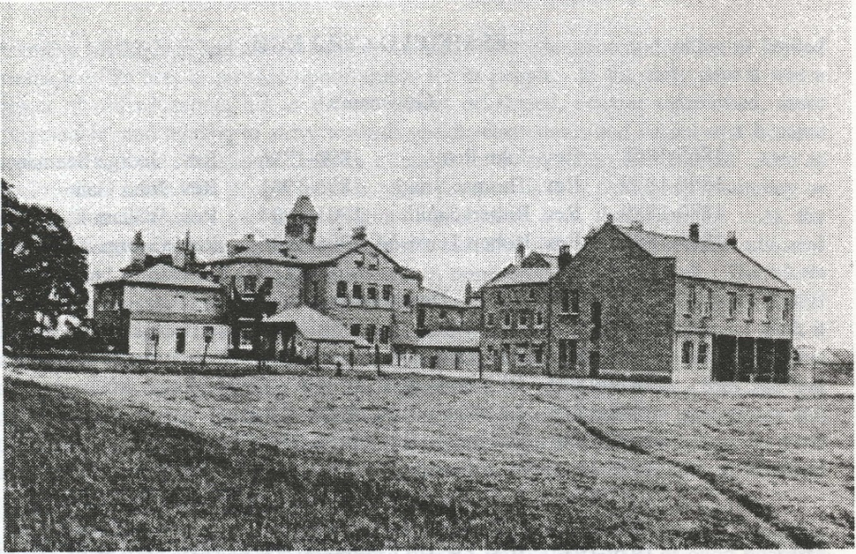

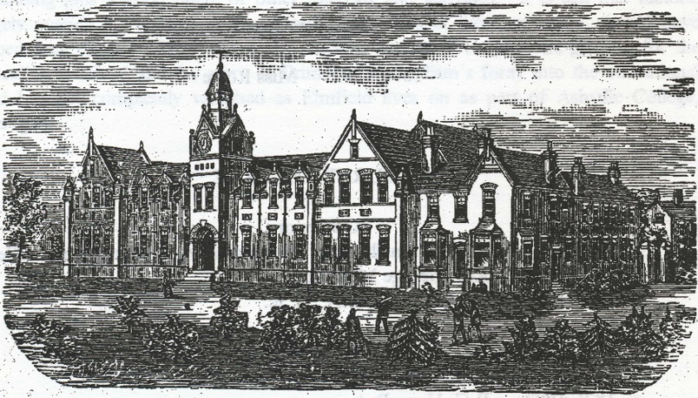
Bourne College

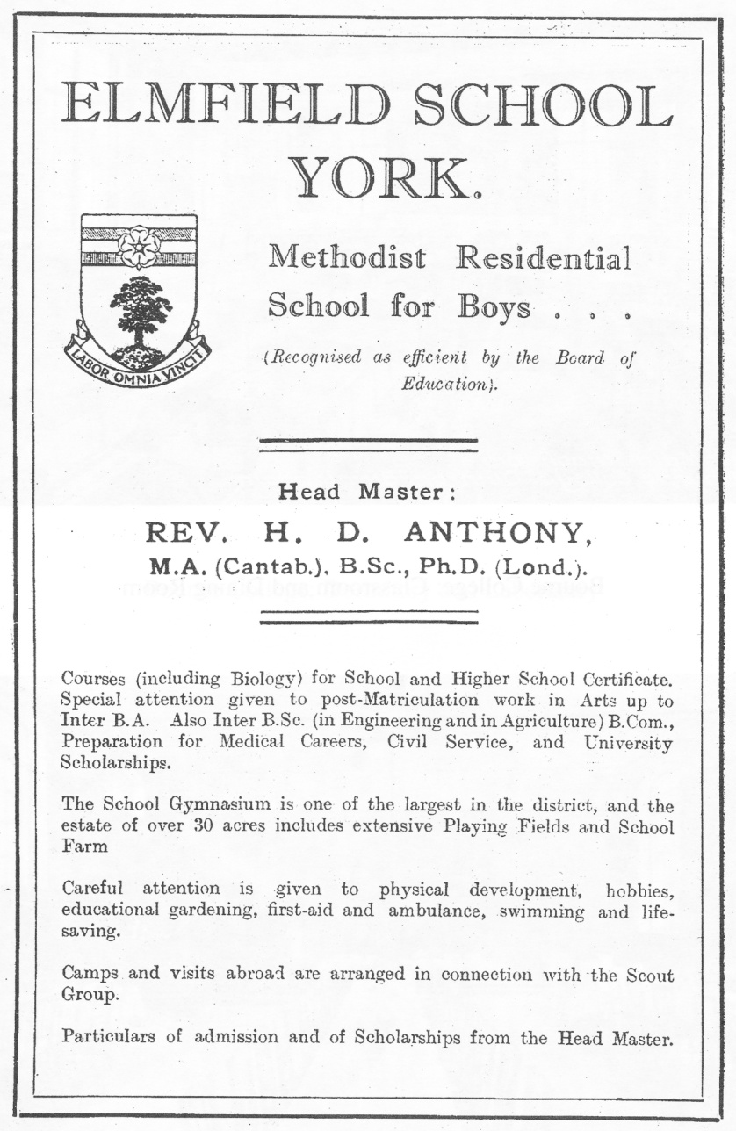
Advertisement for Elmfield College

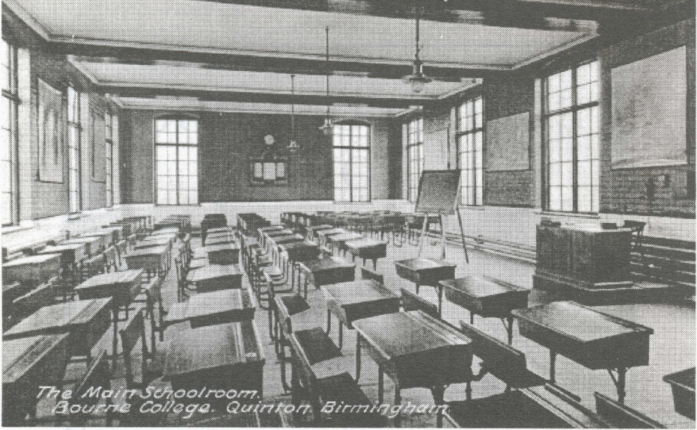
Bourne College: Classroom and Dining Room

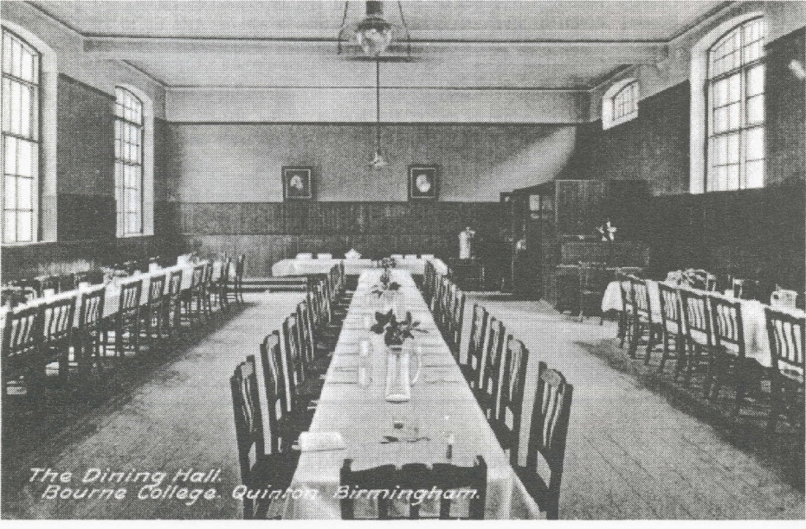

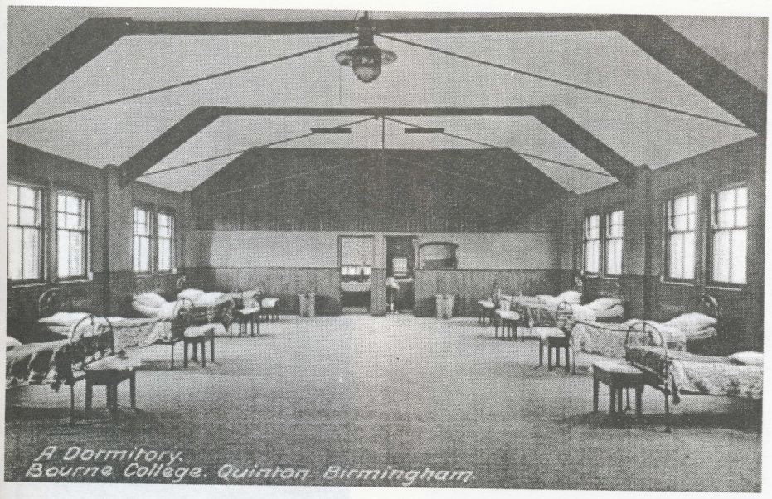Bourne College: Dormitory and Laboratory
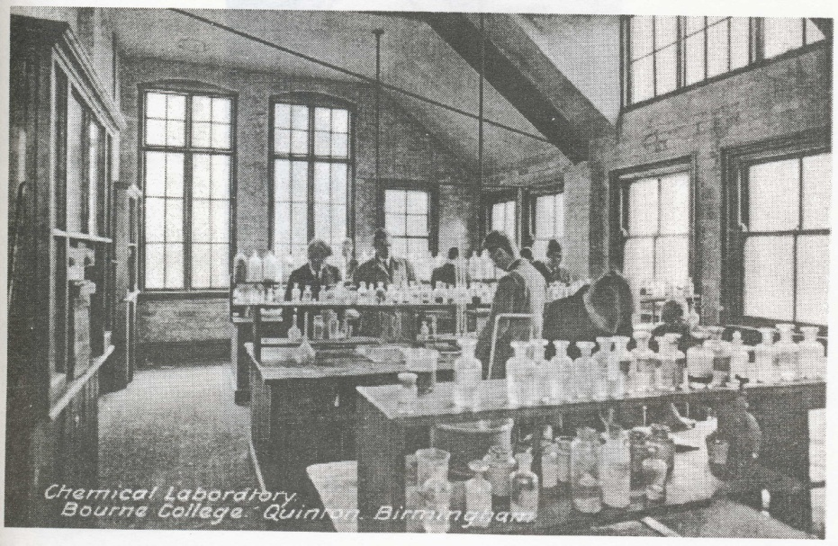

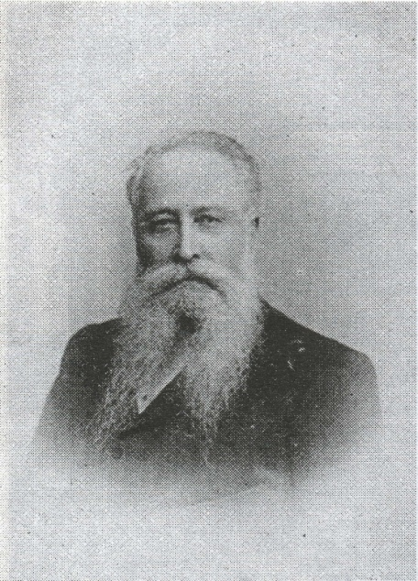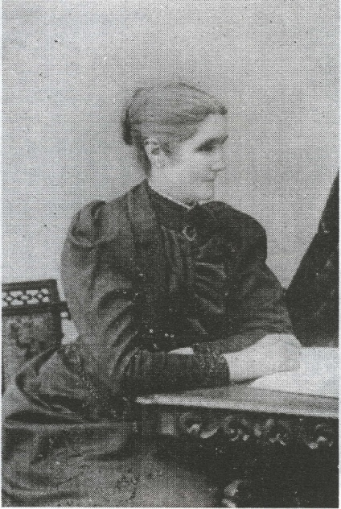
Rev. G. and Mrs. Middleton
Governor and Matron, Bourne College
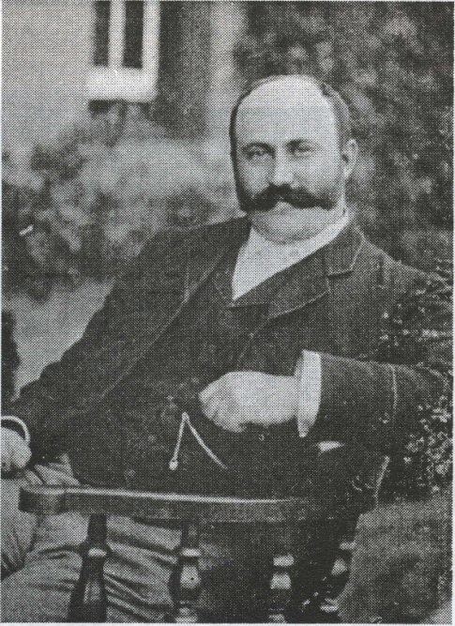
T.G.S. Hooson Esq. B.A.
Headmaster of Bourne College

Dorothy Graham was born in Redditch in 1931. She was brought up on her parents' farms, (one now in the suburbs of Birmingham and the other in Warwickshire) and went from the village school to Leamington College for Girls.
In 1951 she went to Leeds University to read Theology, and, after graduating, began work on a B.D. thesis which, because of Church and family commitments, was not completed until 1965. Its theme was The contribution of Lady Glenorchy and her circle to the Evangelical Revival.
She taught in Scotland and Yorkshire and, in 1965 became Head of Religious Education in a Girls' Grammar School in Birmingham.
She was awarded a Ph.D. by Birmingham University in 1987 for Chosen of God: the female itinerants of Early Primitive Methodism.
She became the Secretary of the Wesley Historical Society (W. Mids. Branch) 1966, General Secretary of the Wesley Historical Society in 1980, and Connexional Archives Liaison Officer in 1989.
Author of various publications and articles on local history. Currently researching Methodist Women, Church Membership, and Methodist Deaconess Orders.
She has held various offices in the Church at every level. She has been a Local Preacher for 44 years 'keeping up the family tradition of preaching which now amounts to well over 300 years.' [N.B. She received her 60 year certificate in 2014]

Bourne MSS (Auto) A & C Texts (MARC)
J. T. Wilkinson, The Life of Hugh Bourne 1772-1852 (1952) pp. 193-4
Primitive Methodist Magazine [hereinafter PMM] (1823) pp. 4, 27-8, 55-57, 79-82, 101-2, 121, 124, 146-9, 195-7; (1824) pp.5-6, 25-7, 49-51, 52, 97-9, 121-2, 122-3, 145 & fn. cf. Kendall, H. B., The Origins and History of the Primitive Methodist Church 2 vols. (n.d. ?1904), I p.31.
PMM (1851) pp. 21-30
PMM (1847) pp.176-7
PMM (1847) pp. 748-9
PM Consolidated Minutes (1849) p.123; Kendall II p. 520
PM Consolidated Minutes (1849) pp. 126-7
Primitive Methodist Minutes. (hereinafter PMMins) (1860) p.38
PMMins (1862) p.30
PMWorld 1883 (May 17) p.314 cf. PMM (1888) pp. 134-6
PMMins (1863) pp.33-4 (1-20)
PMMins (1864) pp.36-7 (1-11)
PMMins (1865) pp.35-38 (18), 96
PMMins (1866) p41
PMMins (1866) pp.44-5
PMMins (1867) p.46
G. E. Milburn A School for the Prophets (Chapel .Aid Lecture 1981)
PMMins (1867)p.80
PMMins (1867) pp.91-2
PMMins. (1868) pp. 12-27 43, 41
PMMins (1869) p.36
PMMins (1869) pp.67-9, 86, 89
PMMins (1925) pp.213, 260-263
PMMins (1870) pp.68-9, 94-5; (1871) pp.61-3
PMMins (1872) pp.63-5, 75
PMMins (1873) pp.67-9
PMMins. (1875) pp.68-70; (1876) pp.70-1; (1877) pp.75-7; PMM(1877) p.250
PMMins (1879) pp.80-1; PMM(1879) p.187
PMMins (1877) pp. 102, 117; (1878) p.102
PMMins (1880) pp. 6-8: PMM(1879) p.637
PMMins (1881) pp. 91-3, (1882) pp. 87-8, (1883) p.81
PMMins (1883) p.80
PMM (1884) p.256
PMMins (1884) p.116
PMMins (1886) p.102
PMMins (1885) p.116
PMMins (1886) p.127
PMM (18 87) p.192
PMMins (1886) p.122, (1887) p.127
PMM (1889) pp. 722-4
PMMins (1891) p.143
PMMins (1892) pp. 153. 6-10, (1895) p.150: Bourne College Chronicle (hereinafter BCC) 5 (1895-1901) pp.161ff
PMMins (1896) pp. 170. 154-6: (1898) p.146, (1899) p.152: PMM (1899) pp.316, 635
PMMins (1901) pp.41, 175-8
PMMins (1901) pp. 18 2-3
PMM(1901) p. 78: PMMins (1902) p.161
PMMins (1902) p. 198
PMMins (1903)p.222
PMMins (1904)pp.l3-15, 19-21, 183-6
The Aldersgate: PMM (1905} pp.369-72
PMMins (1904) pp. 184-5
PMMins (1905) pp.202-4
The Aldersgate: PMM(1905) pp.668-9
PMMins (1906) pp. 179-80
PMMins( 1907) pp. 141. 188-190, 221, 142, 144
PMMins (1908) pp. 194-6: The Elmfieldian (January 1908) pp.2-3, 12-20
PMMins (1908) pp.195-6
PMMins (1909) pp.180-1, 197. 198, 222
PMMins (1912)pp.204
PMMins (1911)p.211
PMMins -(1914)p.220
PMMins (1915) pp.224, 261
PMMins (1916) p.175
PMMins (1916) pp.175-6; (1917)p.l86; (1918)p.l82; (1919) p.l93
PMMins (1919) p.193; (1921) p.188
PMMins (1920) p.188; (1922) p.192
PMMins (1924) p. 197
PMMins (1925) p.207; (1926) p.213 cf. (1898) p.146
PMMins (1918) pp.210-213, 252
PMMins (1929) p.211
I am indebted to Mr. John Lenton for this information
PMMins-(1929)p.l35
I am indebted to Mr. William Booth (Archivist of Ashville College) for information through conversation and in his Ashville College: Centenary History 1877-1977
PMMins (1930) pp.6, 195, 458
WMMins (1929)p.52
WMMins (1930) p.53; (1931) p.50; Uniting Conference Mins. (1932) p.32
UMMins (1932) p. 256, 257
UMMins (1932) p.257
Clyde Binfield, Belmont's Portias: Victorian Nonconformists and Middle-class Education/or Girls (35th Lecture of Friends of Dr. Williams Library, 1981)
PM Consolidated Minutes (1849) pp.126-7 cf. p.4 above
PMMins (1863) p.33 (3)
PMMins (1867) p.46 (16)
PMMins p.92
PMMins (1874) pp.40, 41, 83, 109
PMMins (1875) p.79
PMMins (1876) pp.10, 42, 86, 105; (1914) pp.88-9;
PMMins (1877) pp.82-4; PMM(1877) pp.472, 569-70, 760
PMMins (1878)p.38
PMMins (1878) pp.89-91
PMM (l878)p.l91
PMM p.573
PMM p.191
PMMins (1879) pp.81-84; PMM(1879) pp.502, 572
PMMins (1880) pp.88-90
PMMins (1881) p.93
PMMins (1881) p.94
PMMins (1882) p.4
PMMins (1882) p.l50; (1883) p.l49; (1884) p.l58
PMMins (1885) p.150; (1886) p.168
PMMins (1885) p.116 cf. p.9 fn 35 above
PMMins (1886) p. 122
PMMins (1887) p. 127
PMMins (1888) p.97
BCC4 (1890-2) p.165
PMMins (1898) p.183
BCC 5 (1895-1901) pp.l61ff; Kendall II p.525
PMMins (1876) pp.10, 43
PMMins(1877) p.33
PMMins(1877) p.68
PMMins (1877) pp.16, 106-13
PMMins(1878) p.77
PMM (1877) p.313
PMM (1878) p. 5
MSS Bourne College Entry Book I (1876-92)
PMMins (1878) pp.91-4
PMMins (1879) pp.84-9
PMMins (1879) p.87
PMMag (1879) pp.762-3
PMMins (1879) pp.87-8
PMMins (1881) pp.96-8
PMMins (1882) p.89
PMMins (1883) pp.82-4; BCC 5 (1895-1901) pp.163-4
Birmingham Places and Faces , 2nd November 1891
Kendal I pp. 491-2
MSS - Bourne College Entry Book I p. 5 and examination section at the back.
BCC 5 (1895-1901) pp.241-3
BCC 5 (1895-1901) pp.241-3; MSS - Bourne College Entry Book I pp.9f
PMWorld June 28 1883 p.422
PMMins (1884) pp.96-7
PMMins (1886) pp.127 etc.
PMMins (1887) p.122; (1888) pp.127,130
PMMins (1888) pp.115-16; BCC 1 (1887-8) pp.15,121-6
College Road PM Church Trustees Minutes 1882-1927 (December 1883); BCC 1 (1887-8) pp.155-6; 5 (1895-1901) p.34
BCC 1 (1887-8) p.87
PMMins. (1889) p.l37; (1890) p.l33; (1891) p.147; (1892) pp. 156-58
BCC, 2 (1888-9) pp.156-8, 165; 3 (1889-90) pp.37-8, 169-70
PMMins (1893) pp.l59-161; BCC 5 (1895-1901) p. 136
PMMins (1894) pp.154-7; cf. BCC 5 (1895-1901) pp.29,70
PMMins (1826) pp.154-7; cf. BCC 1 (1887-8) p.28
BCC 1 (1887-8) p.187
PMMins (1894) p.156; PMMins (1895) p.154
BCC 5 (1895-1901) pp.202-7
PMMins (1897) pp.160-4
BCC 5 (1895-1901) p. 243
BCC 5 (1895-1901) pp.244, 262, 282-3
PMMins (1899) pp.154-7
Bourne College Calendar for 1899 pp.8-10
BCC 2 (1888-9) p.85
Bourne College Calendar for 1897 p .23
BCC 5 (1895-1901) p.242; cf. The Birmingham Evening Mail, Friday 7 March 1930
Bourne College Calendar 1909 p.5; 1910 p.6; BCC 5 (1898-1901) pp.227-8
BCC 5 (1898-1901) pp.132; BCC 7 (1908-1913) (1911) pp.20-1, pp.(1909) pp.80-4; .BCC 2 (1888-9) pp. 25,45,46,206
BCC 5 (1898-1901) pp.147, 187
BCC 7 (1908-13) pp.60, 91-3
PMMins (1901) pp.182-3 cf. p.10 above
PMMins (1905) p.205
PMMins (1906) p.181
PMMins (1907) pp. 190-3
PMMins (1908) pp.231, 43, 235, 54 cf. p.l4 above
BCC 7 (1908-13) pp.1-2, 56-7; cf. BCC 4 (1890-2) p.93
PMMins (1908) pp. 181-4; (1909) pp. 197-8
PMMins (1911) pp.213-7; cf. BCC 7 (1908-13) p.75; PMMins (1913) p.230; 1914)p.224
PMMins (1915) p.227; (1917) p.189; BCC 8 and 9 (1913-21) (1916) p.1; (1919) pp.17, 26-32; PMMins (1916) p. 178
PMMins (1918) p.184
PMMins (1919) p.196; (1920) p.191; (1921) p.191; cf BCC8 and 9 (1920) pp.1-2; BCC 10 (1922-8) (1921) p.1; cf. picture facing p.l2; PMMins (1922) p.195
PMMins (1920) p.191; (1922) p.195; (1923) p.192; (1924) p.201
PMMins (1925) pp.209-12
PMMins (1926) pp.215-17
PMMins (1927) pp.215-18
PMMins(1928) pp.213-16
BCC 10(1928)pp.5-6
MSS - Day Book 2 (1893-1928)
PMMins (1929) p.21; Wesleyan Methodist Minutes (1929) p.52 cf. p.l7 above
The Birmingham Post, Friday 22 March 1929
The Birmingham Mail, Friday 7 March 1930; The Evening Dispatch, Friday 7 March 1930
The Birmingham Gazette, Wednesday 25 February 1931; The County Express, Saturday 28 February 1931
BCC 5 (1895-1901) p. 165, gives a summary of the successes achieved between 1876 and 1895. For further yearly listings see the various volumes of the BCC and the Bourne College Calendar. There is also a file of 23 appreciative letters from old boys: of these nine were doctors or connected with that profession, four ministers; three teachers; one musician; the occupations of the remaining five are not identified.

